Cut the end off a garbage bag, and open it out. Place the template along a long edge, and cut around.
Open out the folded shape and run a line of sticky tape along each edge to strengthen.
Insert spars in the dihedral, and cut to length shown in the diagram below. Cap the spars with electrical tape. Use a skewer to make the bridle holes.
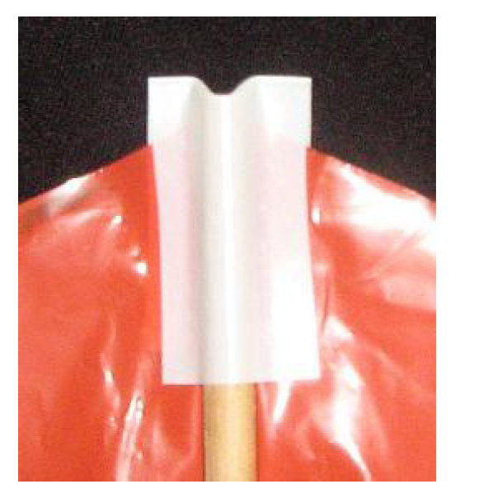
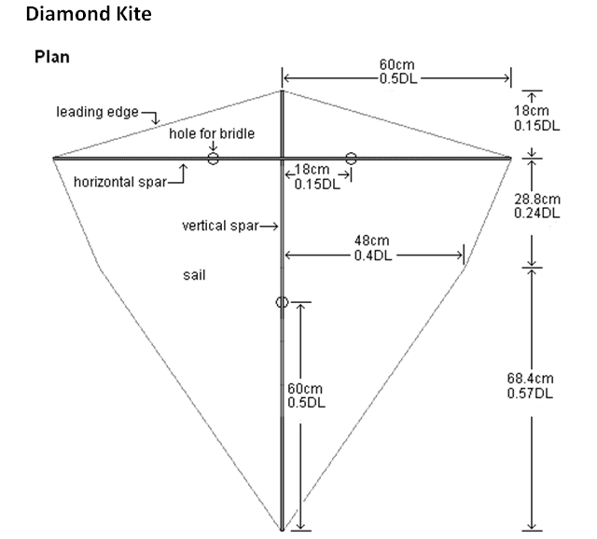

Insert motor into the black poly mounting, and glue in place.
Assemble the Joule thief circuit using the diagram provided, and test before gluing the joints.
Put the circuit in the box, poking the wires through the corners and glue together.

Mount the motor assembly on the under side using wire. You need to poke the wire through the sail and attach to the spars below.
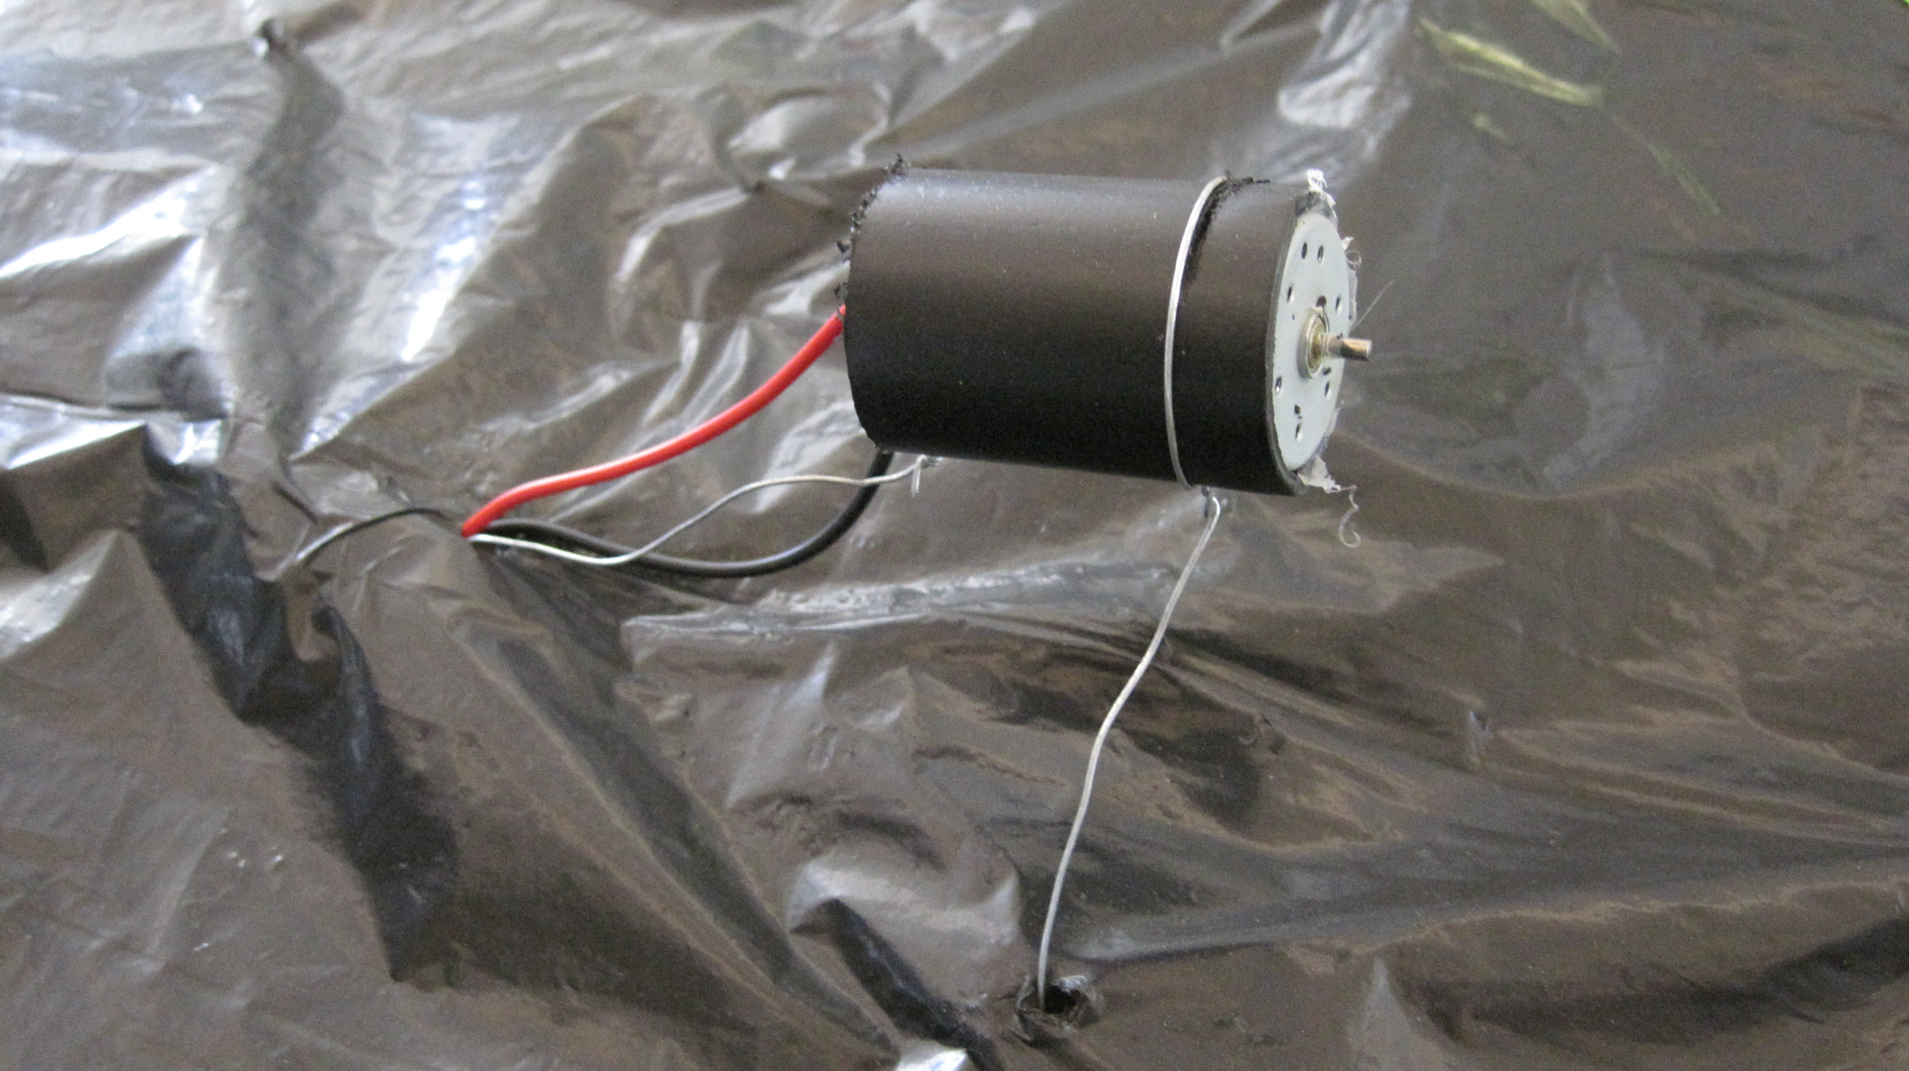

Join the LED harness to the wires coming from the Joule thief on the side with the spars, and test by spinning the motor. The harness can be a tail, or you can poke holes through the sail so the LEDs can be seen from underneath.

Assemble the propeller by aligning using two pieces of wire inserted through the holes as you glue together. Cut blades from material provided, and glue them in place. Test again (you may need to swap the wires attaching the LEDs, depending on which way the propeller spins).

Cut lengths of string and assemble the bridle as shown below. Instructions for the Prusik knot are separate.

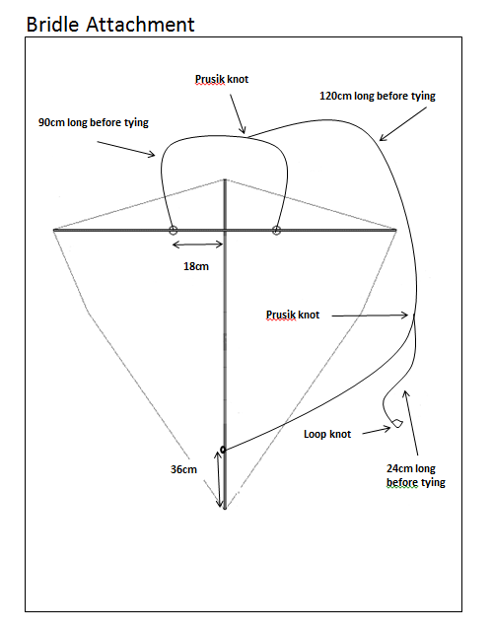

Attach the flying line on the winder to the loop knot, and wait for the wind!

