The Edge Plastic Shredder Induction

ACTIVITY 1: Key safety tips for safe working with the plastic shredder
Draw a line to match the safety tip with an explanation

Wear the correct PPE
(safety glasses, ear muffs, dust mask, footwear) Shocks and shatters come from faulty equipment

Present yourself with safety in mind
(remove rings and jewellery, tie back loose clothes, long hair and beards) It’s there for your protection

Check the tool is in good condition
(ensure safety guards are functional, avoid blunt or broken tooling) Slips, falls and distractions cause accidents

Prepare a tidy and safe work area
(remove loose material and debris, ensure stable footing) Avoid tangle hazards
ACTIVITY 2: Key safety checks for using the plastic shredder. Draw a line to match the checkpoint with what to look for

Obtain the master control key from the Lab supervisor
Check the safety shields are in place and functioning, and blades are undamaged and unclogged
Make sure the workplace is clear and familiarise yourself with the on/off and emergency stop switch.

Check the wheel locks are engaged and the machine is fully charged.
Place a collecting container beneath the shredder.
Ensure the feed assist push stick is on hand.
Disconnect inverter (charger) and attach motor to battery using the push connectors

Start the shredder by turning the master key one quarter turn clockwise
Set to forward with forward/reverse switch
Switch on grinder in forward motion with motor on/off switch.
Feed material into the grinder piece by piece keeping hands outside the safety shield
Use push stick to engage material with cutting blades if necessary
During the job

Completing the job

Starting the job
Do not reach into the hopper or remove cut material while grinding
If jamming occurs, switch off the motor before briefly engaging reverse to clear the cutters
Adjust collecting container as required to avoid spillage
Turn off immediately if overheating occurs, and contact Lab supervisor

When finished, run the grinder for a minute or two to clear the screen
Turn grinder off before brushing down screen and grinder blades
Reconnect battery lead to the charger and remove master control key for return to Lab supervisor
Sweep work area if necessary, to leave a clean workspace
Prepare the material

Before connecting the power

ACTIVITY 3: Identify the important components of the plastic shredder
9
10
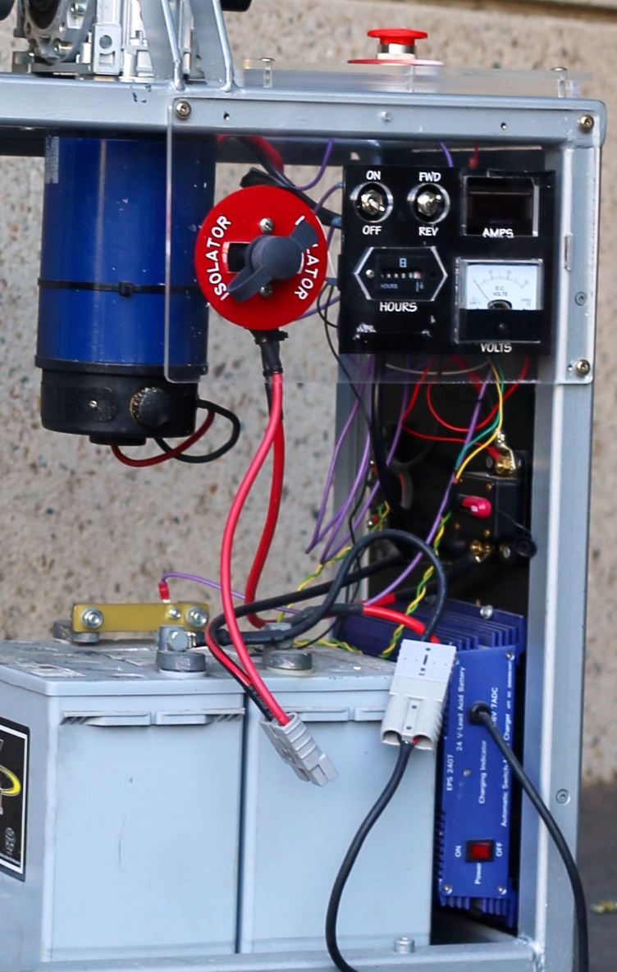
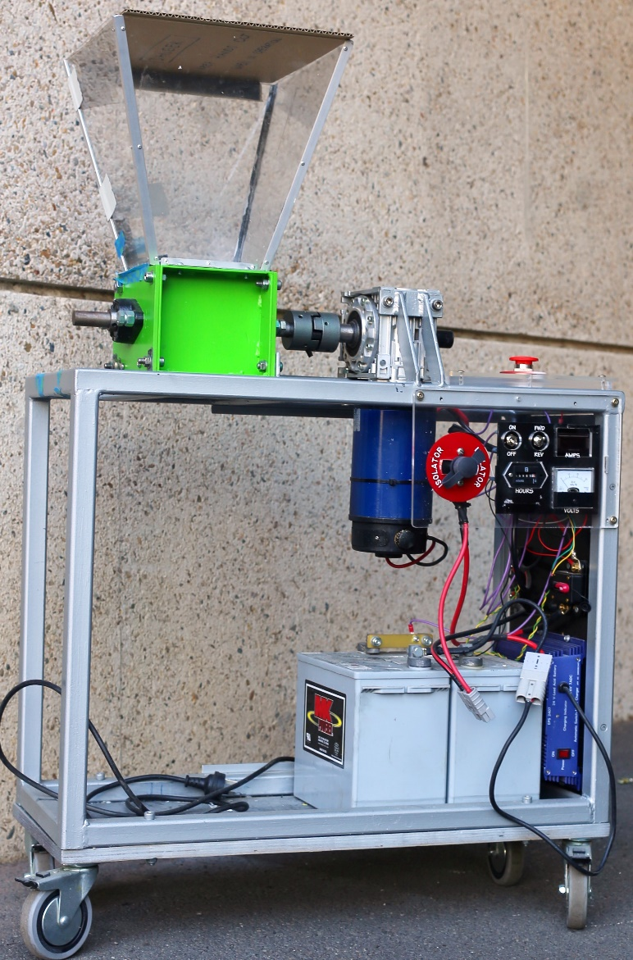
Choose the correct name from the list to identify the key parts numbered in the picture.
2

_____ Hopper
_____ Wheel lock
_____ Master Control Key
_____ Motor On/Off
_____ Forward/Reverse
_____ Battery push connector
_____ Emergency Stop
_____ Grinding blades
_____ Safety shield
_____ Inverter (charger)
3

4

5

1
6
7
8
Activity 4: Demonstrating safe use of the plastic shredder
- Ensure correct PPE is being worn, and the tool and workspace is safe to use.
- Engage wheel locks, locate push stick and mount the master control key.
- Connect battery to motor and set up collection container.
- Start shredder and begin feeding material through safely.
- Monitor for overheating and deploy push stick as required.
- Demonstrate how to clear a jam.
- Finish shredding, clean screen and reconnect charger to battery
- Tidy up and return master control key to supervisor.

Facilitator Observation:
I confirm that the observations made of the participant and active participation in this induction workshop demonstrated a satisfactory understanding, including competent and safe use of the plastic shredder.
Signature:________________________________________________________________________________ Date__________________________

Participant Declaration
I declare the assessment above was my own individual work.
Signature:_________________________________________________________________________________ Date__________________________

