Ebooks, eaudiobooks and eresources
State Library of Queensland
Online collections and resources training

Access thousands of ebooks, eaudiobooks and eresources for FREE through your library membership.

Contents
- What is an eresource? 1
- ebooks – via your State Library of Queensland membership 1
- ebooks – via your public library membership 9
- ebook apps 11
- ebook websites 13
- ebook websites for kids 14
- eaudiobooks - via your public library membership 15
- Music via your public library membership 16
- Databases – via your State Library of Queensland membership 17
- elearning websites 19
- eresources - via your State Library of Queensland membership 20

What is an eresource?

The term “eresources” describes a wide range of electronic resources and information that you can access online via your public library membership or via One Search (http://onesearch.slq.qld.gov.au), State Library of Queensland’s library catalogue. Eresources include:
- databases of journal articles
- newspapers
- company and industry data
- music scores
- sound recordings
- ebooks, eaudiobooks
- E-journals – scholarly journals
- Online reference material such as encyclopaedias and directories

ebooks - via your State Library of Queensland membership

As Queensland’s premier information and reference library, State Library of Queensland offers access to information and reference based eresources.

To access eresources offsite via One Search you must have a State Library of Queensland membership. If you don’t have a State Library membership please join (https://www.slq.qld.gov.au/get-involved/become-member) before starting this training session. State Library of Queensland membership is free and you can set up an account online, the only condition is you must be a Queensland resident.

Video Tutorial – How to find ebooks (2mins 14sec) - https://www.slq.qld.gov.au/research-collections/information-collections/eresources/ebooks

State Library of Queensland provides access to ebooks via the library’s catalogue, One Search (http://onesearch.slq.qld.gov.au). For more information on using One Search see the One Search help page (https://www.slq.qld.gov.au/research-collections/one-search-catalogue/one-search-help).

State Library subscribes to ProQuest Ebook Central. In One Search you can also find free ebooks from the Hathi Trust and Project Gutenberg, in addition to digitised books and 'virtual books' from our collections. Ebook titles may appear in the results of a generalised search in the catalogue, or you can limit your search to find only ebooks.

Step by step instructions are below on how to search for ebooks using One Search.

- Load the One Search catalogue page - http://onesearch.slq.qld.gov.au or access via State Library’s website www.slq.qld.gov.au, click on Research & Collections > One Search (Catalogue).

- Limit your search by selecting Advance Search

- Once in Advanced Search refine your search from the dropdown menu by selecting Material type ebooks

Search for your topic of interest e.g. ancient Rome.

- When you find the book you want, click on the title, displayed in blue for more information or click Online access.

- To gain access to the ebook you will need to login using your State Library of Queensland Membership Username and Password. You will then be redirected to the ebook.

- o view the ebook you can choose to either Read Online or undertake a Full Download of the ebook to read later.

- Clicking Read Online allows you to open the book and navigate the text using the chapter links on the left hand side.

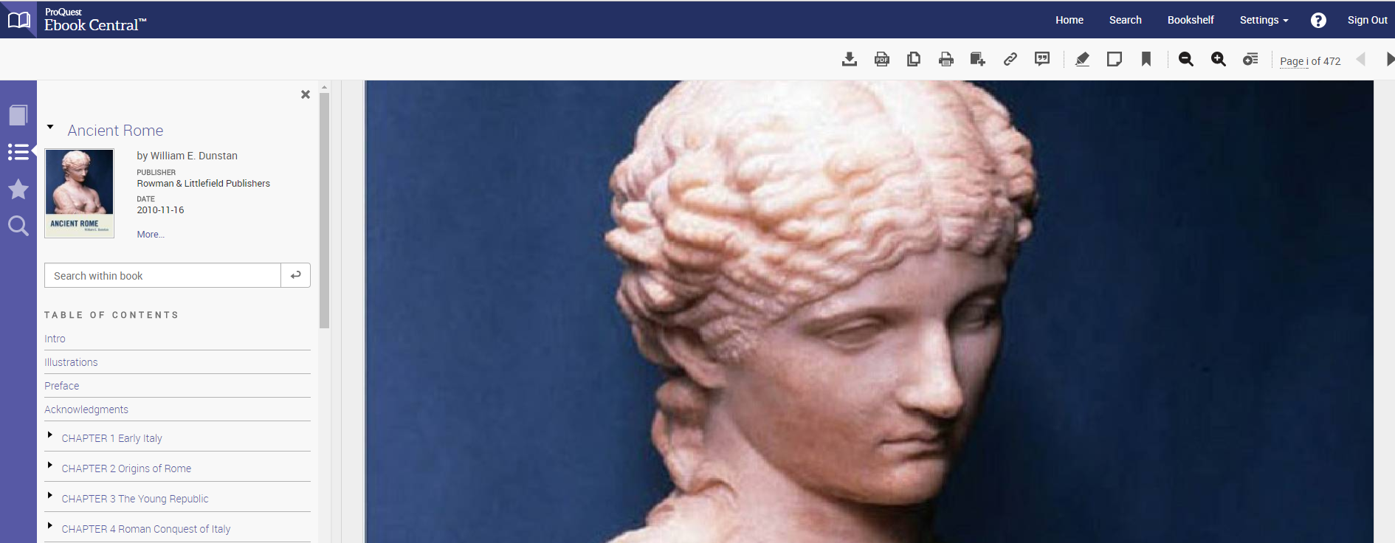
Reading an ebook online via Proquest’s website there are a number of features you can utilise:

Buttons on the left hand side:
- Book Details: this button shows you the ebook’s details (author, publisher, date published etc.), loan information (how many days left in the loan) and your copying/ printing allowance (how many pages you have left to use before you reach the limit – 20% of the book for printing, 5% of the book for copying)
- Table of Contents: This button takes you to the ebook’s table of contents which has links to content in the ebook allowing easy navigation.
- Annotations: This button takes you to a listing of your bookmarks, notes and highlights.
- Search within the book: This button gives you a search bar where you can input keywords to conduct a search of the text in the ebook for content you’re interested in.
Buttons on the top right side:
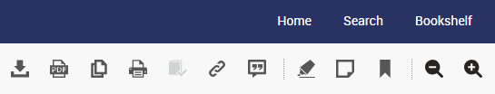

- Full Download: This button allows you to download the full version of the ebook to view later offline
- Chapter Download: This button allows you to download only the chapter you are viewing to view later offline.
- Copy: Highlight text in the ebook with your mouse and click copy so you can paste the text into an external document.
- Print: This button will let you print content you are viewing. Note there is an allowance on the amount of pages you can print. 20% of the book.
- Add to Bookshelf: This button saves the book to your bookshelf, you can click on bookshelf and view books you have saved creating your own library of ebooks for easy access.
- Share Link: This button allows you to copy the internet link to the ebook which you can email or post on social media, sharing the link to the ebook for others to access.
- Get Citation: This button gives you the reference citation for the content you are viewing in the book.
- Highlight: Highlight text in the ebook, click this button and the text will automatically be saved in your Annotations.
- Add Note: This button allows you to make notes in the ebook. A list of all your notes can be accessed via the Annotations button.
- Bookmarks: This button allows you to bookmark a page when reading the ebook. You can access your bookmarks via the Annotations button.

- To save the book to read later, click on Full Download.

To download and save the ebook there are a number of steps:

- A message will appear asking if you want to Open Book. Once clicked the book will open.

- Click on the down arrow on the left side of the screen to download the book.

- Choose your device from the list displayed.

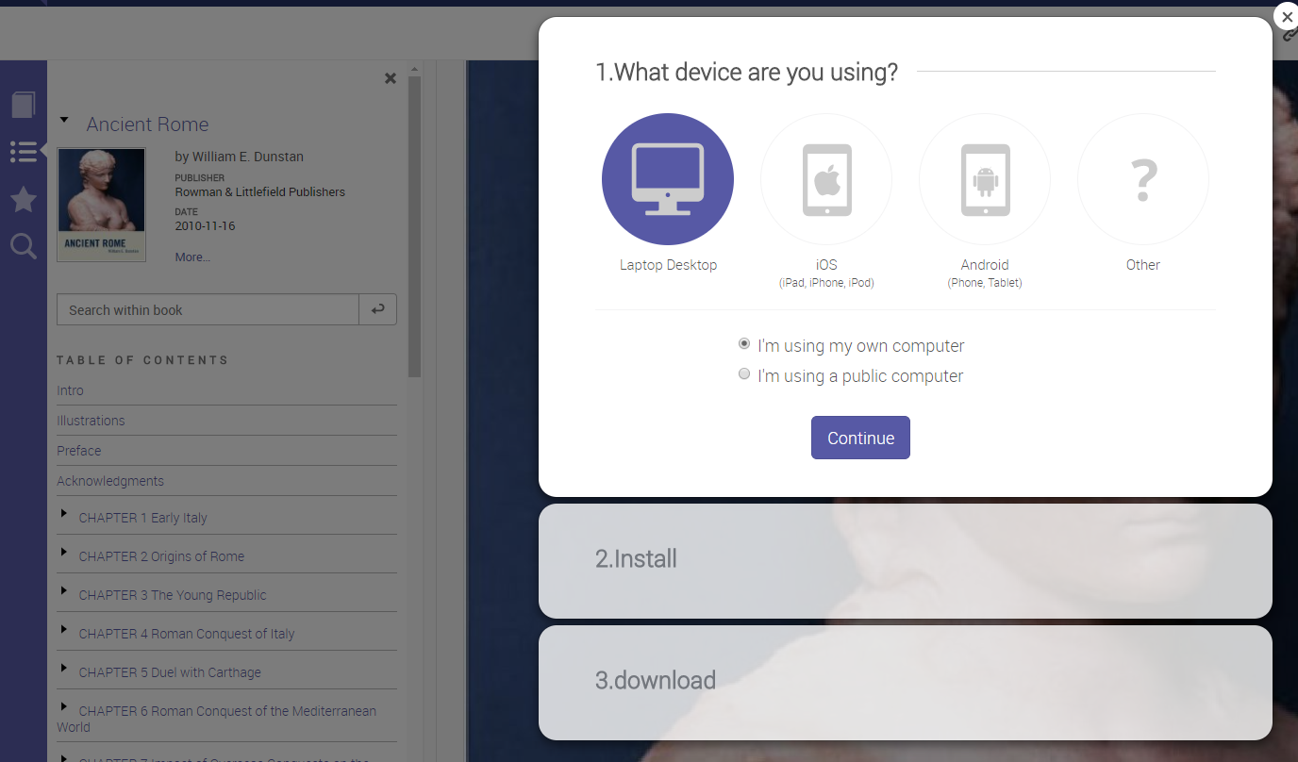

- Download free Adobe Digital Editions if not previously downloaded.

- Finally select your loan period and download the item. Note option to download as an EPUB or PDF.

Useful information about downloading ebooks.

ebooks can be downloaded on mobile devices including:
- Apple IOS devices such as IPad, IPhone, IPod, and
- Android devices such as phones and tablets.

To access ebooks on a mobile device you will be required to download the free app called Bluefire Reader software.

When using a mobile device to download ebooks you will be prompted to download a free digital viewer compatible with your device (eg Adobe Digital Editions software).

Ebooks - via your public library membership

Your State Library and public library memberships offer different access to different eresources. While State Library offers access to information and reference based ebooks, your public library membership will offer access to ebook providers offering popular fiction and non-fiction content.

The list of eresource providers you can access with your public library membership can be accessed via your public library catalogue and webpage.

Download the eresource apps to your mobile device for easier access. You need your library barcode and PIN to get started and you must have Adobe Digital Editions or Bluefire Reader downloaded before you borrow. Apps are available free from the App Store (iPad or iPhone) or Play Store (Android).

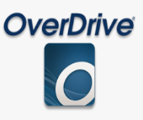
Library ebook providers include:
OverDrive digital collection has fiction & non-fiction titles including curated kids and young adult fiction and non-fiction.
- Read straight from your browser or download to your computer or mobile device.
- For browser-based ebooks you need an up-to-date web browser.
- For downloadable ebooks: Adobe Digital Editions (Window or Mac) or OverDrive for Windows 8 (Windows 8/RT only).
- Use the OverDrive or Libby app.

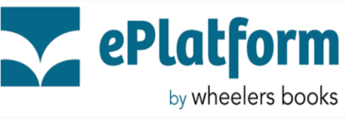
ePlatform by Wheelers books
Top Australian content: rural romances, biographies, crime and thrillers.

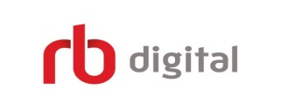
RBdigital emagazine

Newspapers and magazines available including popular subjects such as craft, travel, horsemanship, outdoor living.
- Create an account in your browser. All users need their own account. You need to do this once.
- Install the RBdigital app. You can then download titles to your mobile device.
- Sign in using your existing log-in credentials.
- Select Magazines to browse the emagazine collection.
- Browse to sort or filter your selection or search by title.
- Checkout a magazine of your choice.
- Select the prompt to be emailed when next issue is available if you want to keep that magazine as a favourite.
- Select Read to download.
- Keep favourite titles in your own Library and receive email alters when the latest issues arrive
- NOTE: Via your State Library of Queensland membership you can access Press Reader another emagazine and enewspaper provider. Press Reader has over 7200 titles available in more than 30 languages from over 50 countries. Includes many regional Queensland newspapers. “Discovering PressReader” is available as a separate training session

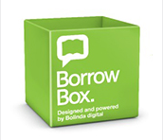
BorrowBox
Latest Australian titles available online or via the app.
- Borrow and download to your favourite device. Your loan details will be emailed to you.
- Download an eaudiobook a chapter at a time or download the whole book
• Use Adobe Digital Editions software to read ebooks on your computer or transfer titles to your ereader device.
• Titles will appear automatically in your list of current loans in the BorrowBox mobile app
- When your loan period is up, you will receive an email as a reminder to delete the file.

Kids ebooks

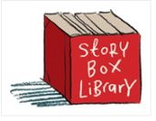
Storybox Library
Story Box Library provides a vibrant, interactive experience via a diverse range of everyday Australian storytellers.

- There is no app available for Story Box. Access is via your web browser either on your computer or mobile device.
- Browsers and media supported include Chrome, Internet Explorer, Firefox, Safari, IOS and Android.
- Story Box Library offers live streaming. Streaming means watching the video in ‘real time’ instead of downloading a file to your computer and watching it later.

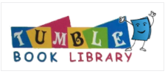
Tumblebooks
W: http://www.tumblebooklibrary.com/Home.aspx?categoryID=13

A selection of ebooks developed especially for children. Listen and watch ebooks online, read a review, write a book report and play games. Bilingual titles are available to support language learning in Spanish and French.
- Use your local library barcode number to login.
- Download the Tumblebooks App to view on your mobile device.

Ebook apps

There is a range of apps you can download to your mobile device that will help you read ebook files or you can use to download additional ebooks outside of the resources provided by State Library. Some apps will require you to purchase the ebook before letting you download the ebook to your device.

Not all of these apps may be available to download to your device, it depends what operating system and app store you have access to from your device (eg Apple app store or Google Play for android)

Bluefire reader app
This app allows you to read ebooks for Android, iOS and Windows, mobile devices, tablets including Amazon Kindle. It supports EPUB and PDF formats for digital publications. You can use this app to read State Library of Queensland’s ebooks.
http://www.bluefirereader.com/

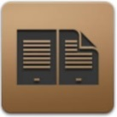
Adobe Digital Editions
When using a mobile device to download ebooks you may be prompted to download a free digital viewer compatible with your device (eg Adobe Digital Editions software). Overdrive and Bluefire require this application.
https://www.adobe.com/au/solutions/ebook/digital-editions.html

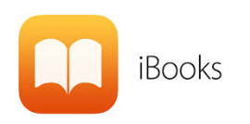
iBooks
This Apple iBook app allows you to download books on iPad, iPhone, iPod touch and Mac computers. It has a bookshelf, tap a book to open, flip through pages with a swipe, bookmark and more
http://itunes.apple.com/au/app/ibooks/id364709193?mt=8

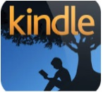
Kindle app
The Kindle is an Amazon e-reader which enables users to download free and paying to use ebooks, newspapers, magazines and other digital media via wireless networking to the Kindle Store. The device allows users to browse, buy, download and read ebooks. Amazon Kindle allows download to iOS, Android, Mac & PC, tablets or smartphones running the Kindle app and Google Play
https://www.amazon.com.au/kindle-dbs/fd/kcp

Free Kindle ebooks
Free Kindle books on Amazon. It allows Kindle users to download free books for computers and smartphones, tablets, including Mac, Windows iOS, Android, and Blackberry operating systems.
https://ebookfriendly.com/download-free-kindle-books/

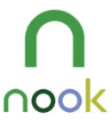
Nook app
Nook is a free app by Barnes and Noble an online book store.
Free and paying ebooks are available from Barnes and Noble. Can be downloaded on iPad, Android and Google Play.
https://www.barnesandnoble.com/b/nook-books/free-ebooks/_/N-8qaZry0

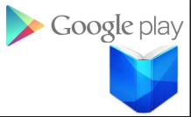
Google Play app
You can install the Google Play app to read books on an Android and iPad/iPhone and laptop or computer. Google Play allows user to download ebooks, eaudiobooks, music, movies, TV, magazines, newspapers, games and more. Free and paying ebooks are available.
https://play.google.com/store/books

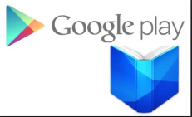
Free Google Play books
Access free ebooks and eaudiobooks. Google books allows public-domain works and other out-of-copyright material to be downloaded in PDF format and more https://play.google.com/store/books/collection/topselling_free?hl=en

Kobo App
The Kobo app allows access to ebooks and eaudiobooks for free and paying options. They are compatible for tablets, smartphone, iOS, Android, Blackberry, Windows and desktop PCs. Kobo supports documents in PDF format via the app. To access EPUB files use your PC.
https://www.kobo.com/au/en

Ebook websites

There is also a range of recommended ebook websites where you can view, download free or purchase ebooks.

Trove
Trove is a searchable collection of digitised newspapers, government gazettes, journals, articles and data sets, books, pictures, photos, objects, music, sound and video, maps, diaries, letters and archives. It includes Women’s Weekly editions from 1933-1982 and is collated by the National Library of Australia.
http://trove.nla.gov.au/

British library classics
The British library website has a small ebook collection of unique historical importance.
http://www.bl.uk/onlinegallery/virtualbooks/index.html

Free-ebooks
Free-ebooks is an online source for free e-book downloads, ebook resources and ebook authors. Besides free ebooks, you can download free magazines or submit your own ebook.
http://www.free-ebooks.net/

ebooks.com
Every book has Australian licensing, full range of subjects in fiction and nonfiction, classics, textbooks, academic, ebooks and eaudiobooks for adults and children.
http://www.ebooks.com/

Feedbooks
Download free recently published books in the public domain or purchase ebooks.
http://www.feedbooks.com/publicdomain

Smashwords
Download free recently published books and ebooks in the public domain or purchase elbooks
http://www.smashwords.com

Google books
A web search engine by Google especially for books. Google digitizes books from different sources and then makes them available on its server. Google books allows public-domain works and other out-of-copyright material to be downloaded in PDF format and more. Books can be downloaded onto a PC or mobile device for android and Apple devices.
http://books.google.com/

Manybooks
An ebooks website that contains non-fiction and fiction materials for the internet reader.
http://manybooks.net/

Project Gutenberg
Project Gutenberg allows you to download over 57,000 free ebooks to read on your PC, iPhone, Kindle, Sony Reader or other portable device. It has the largest collection of public domain books, including books from authors such as William Shakespeare, Mark Twain and Charles Dickens.
http://www.gutenberg.org/wiki/Main_Page

Project Gutenberg Australia
Building on the concept of Project Guttenberg this site includes a library of Australiana.
http://gutenberg.net.au/

Internet Archive
Is a library of free books, movies, software, music, websites, and more.
https://archive.org/

Readprint
Free online library for students, teachers, and the classics enthusiast. Thousands of stories, poems and novels are listed.
http://www.readprint.com/

Ebook websites for kids

International children's digital library
Promoting reading to children of all ages, the books have an international focus with a range of languages covered.
http://en.childrenslibrary.org/

Eaudiobooks – via your public library membership

An audiobook is a sound recording of a book sometimes known as a talking book. Audiobooks come in several different formats to allow playing on difference devices: eAudiobooks, CDs, MP3 CDs, tapes and Playaway audiobooks. An eaudiobook is a downloadable audiobook.
Eaudiobooks are a useful alternative to books on CD. There is a great variety of content available, including all the latest Australian titles.

Library members need their public library barcode and PIN to get started to create an account. Selections can be made from the platform web address or by searching for titles in their library catalogue. Free apps are available to download for each platform (Android and IOS).

Audiobook providers available through your public library membership include:

Overdrive

OverDrive doesn’t just have ebooks but eaudiobooks as well.

- You need a valid library barcode and PIN to borrow titles.
- Eaudiobooks can be streamed or download to your computer or mobile device.
- Use the OverDrive or Libby app.
- Refine your collection to eaudiobooks to see available titles.
- Help is available via https://help.overdrive.com/customer/en/portal/articles/1481727-get-help-with-eaudiobooks-from-overdrive

Borrow Box

- eaudiobooks available including the latest Australian titles for downloading.
- Library members can download to their MP3 device or Windows PC/Mac.
- Reserve titles already on loan.
- Use the Borrow Box App.
- Help is available online

Eaudiobook websites

Librivox
A free out-of-print audio book website that provides public domain books available online. With price comparisons, list of devices and formats.
http://librivox.org/

Music – via your public library membership

Freegal Music

Freegal is a downloadable music service available free to public library members
- , with access millions of songs from Sony Music’s catalogue of artists
- Download songs per week or stream hours of music every dayUse the Freegal app or access via the web
- Search the collection and preview songs.
- Be sure to check out the browsing areas, especially Artists A to Z and the genre lists.
- Create your own playlist for easy streaming.
- Keep track of your downloads in the upper right corner of the site. A counter notifies usage. The download counter resets each week at Monday 16.01 Easter Standard Time (Brisbane, Australia).
- Click on Download Now – the song is yours to play and keep. Or click the Stream Now button to start listening. If you click on an album, the whole album will play in order.
- Downloaded songs to your computer will play in Windows Media Player, iTunes, and other popular music players. Downloaded music can also be transferred to an MP3 player or iPod or burnt to a CD. Songs downloaded are all in MP3 format with no DRM (Digital Rights Management).
- Help is available online.

Databases – via your State Library of Queensland Membership

The State Library of Queensland offers access to a range of information and reference databases.

These databases include - journal articles, newspapers, company and industry data, music scores, sound recordings, ebooks, scholarly journals in a wide range of subject areas published online, online reference material such as encyclopaedias and directories.

- Databases are accessible via One Search (http://onesearch.slq.qld.gov.au) State Library’s catalogue OR
- Can be browsed via the State Library’s databases website, where links to the databases available are sorted by subject areas. https://www.slq.qld.gov.au/research-collections/information-collections/eresources/databases
- Access is provided by login in via your State Library of Queensland membership.

Some databases can only be accessed onsite at State Library’s building in South Bank, however most are accessible state-wide. There will be a note letting you know which databases are onsite only. Some databases have a set number of licenses only allowing a certain number of people to access the database at the same time.

The subject area’s for databases include:
- Art and architecture
- Business and economics
- Family history (Note: Discovering family history resources is available as a separate training session) Ancestry.com and Find my past is only available onsite at State Library’s building in South Bank. To access Anestry.com offsite logon through your Rural Libraries Queensland membership.
- Health
- History, geography and biography
- Humanities
- Aboriginal and Torres Strait Islander Australians
- Music
- News
- Politics and government
- Reference
- Science and technology history (Note: Discovering Lynda.com is available as a separate training session)
- Social sciences

Times Digital Archive together with Trove (http://trove.nla.gov.au/newspaper) and Ancestry are great tools for family history research. Note: Accessing family history resources is available as a separate training session.

Ancestry Library Edition can be accessed for free onsite at the State Library of Queensland at any Queensland public library. An Ancestry.com private membership is $30 a month or $140 for 6 months so accessing the database for free at your local RLQ library can be a big saving.

Lynda.com and GCF LearnFree.org are great sources for web-based professional online learning databases. Note: Accessing Lynda.com is available as a separate training session.

Lynda.com

- Lynda.com is a web-based video subscription service with thousands of courses and video tutorials on the latest commercial software, creative and business skills.

  - Create a profile to begin using Lynda.com.
  - Available on almost any browser-equipped device, including desktops, laptops, smart phones, and tablets
  - Download the app to use from your preferred device
  - Guided tour, mobile site video.
  - A great tool for professional development
  - New courses added regularly
  - More information on how to access Lynda.com via your SLQ membership -
https://www.slq.qld.gov.au/research-collections/information-collections/eresources/lyndacom/lyndacom-frequently-asked-questions

Elearning websites

GCFLearnFree.org
W: https://www.gcflearnfree.org/

Free self-paced tutorials and online classes on a range of topics including technology and Microsoft Office tutorials, as well as math, career, reading, everyday life skills and more
- Click on your preferred tiles from the homepage and start on your way
- View one lesson or an entire tutorial
- No need to create an account or sign in
- Access to well-crafted lessons, practice files, challenges, and quizzes to assess your own knowledge
- Apps available for iPhone/iPad, Android, and Kindle
- Learn for free anytime, anywhere
- Start learning immediately.

Be Connected

W: https://www.beconnectednetwork.org.au/

Australian Government initiative to support digital literacy for older Australians.

Be Connected comprises a website with advice and learning resources.

The Be Connected Network is coordinated by the Good Things Foundation.
- free, interactive webinars about the Be Connected Network and digital skills training.

Eresources - via your State Library of Queensland Membership

Your State Library membership gives you access to eresources such as Kanopy, Naxos Music, Australasian Video Online.

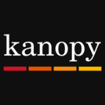
Kanopy is an online film streaming platform, showcasing more than 30,000 of the world’s best films. Among these are award-winning documentaries, rare and hard-to-find titles, film festival favourites, classic films, and world cinema.
- Available on desktop, mobile and tablet.
- To access Kanopy, create a personal profile.
- Download the Kanopy app to watch films on any device.
- Available to State Library and Queensland public library members.

Naxos Music Library [NML] is the world´s largest online classical music library.
The library offers the complete Naxos and Marco Polo catalogues plus the complete catalogues or selected titles from over 650 record labels, with more labels joining every month. Along with classical music, jazz, world and pop/rock are also represented.
- offers streaming access
- new content is added to the library every month.
- can be accessed from any computer, anywhere, anytime
- iPhone/iPod and Android mobile apps
- search by composer, work, genre and label
- create personalized playlists or use predefined NML playlists.

Australasian Video Online is a multidisciplinary collection of videos from top regional publishers. It has a large collection from the National Film and Sound Archive (Australia).
- Covers a broad range of topics with special emphasis on indigenous issues, cultural and environmental studies, anthropology, immigration and Asian studies
- designed for integration into the undergraduate curriculum
- able to build course-based playlists and integrate clips to enhance classwork
- utilize teaching guides that aid deeper conversations around content.

Need further information? Ask us.

(07) 3840 7810 | https://www.slq.qld.gov.au/plan-my-visit/services/ask-us

