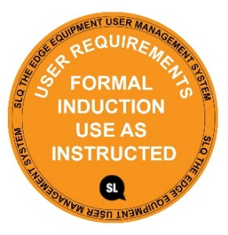

**SAFE OPERATING PROCEDURE**

**SEWING MACHINE/OVERLOCKER**

DO NOT use this machine unless you have completed an induction and the Supervisor and has given you permission

|  |  |
| --- | --- |
| Appropriate footwear with substantial uppers must be worn.Foot Protection circle | Hair Protection circleLong and loose hair must be contained or restrained. |
|  | ApronClose fitting, protective clothing or a workshop apron is encouraged. |

### **PRE-OPERATIONAL SAFETY CHECKS**

**1. Ensure no slip/trip hazards are present in workspaces and walkways.**

**2. Set up a working station with enough room to work freely.**

**3. Before using, always inspect for damage or disrepair, including power cord.**

**4.** **Inspect all machine setting & adjustments and modify as necessary for sewing task.**

**5. Inspect the needle to make sure it’s not bent, dulled, or damaged. Never use a bent needle.**

**5. Faulty equipment must not be used. Immediately report suspect equipment or tools.**

#### OPERATIONAL SAFETY CHECKS

**1. Only use a sewing machine for its intended purpose.**

**2. Use the proper type and size needle for the fabric being sewn.**

**3. For zig-zag or any other special stitching, use a throat plate that accommodates a wide stitch.**

**4. Don’t work with oily or greasy hands.**

**5. Always maintain a safe zone, of about one inch, where fingers never enter when in operation.**

**6. Never sew across pins. Carefully use straight pins & when done, place in proper storage containers.**

**7. Never look away from the machine while it is sewing. If you need to look away, stop sewing first.**

**5. Cut away from yourself when using knifes, and other edged tools.**

**6. Handle sharp-edged and pointed tools with care.**

#### HOUSEKEEPING

1. **Return all equipment and accessories to the appropriate storage.**
2. **Leave the work area in a safe, clean and tidy condition.**

## POTENTIAL HAZARDS

**◼ Cuts (sewing, needles & Scissors) ◼ eye strain ◼ crush injury**

|  |  |  |
| --- | --- | --- |
|  |  |  |

This SOP does not necessarily cover all possible hazards associated with the tool and should be used in conjunction with other references. It is designed to be used as an adjunct to teaching Safety Procedures and to act as a reminder to users prior to tool use.

© State of Queensland (State Library of Queensland) 2020

This policy is licensed under a Creative Commons Attribution 3.0 Australia licence. You are free to copy, communicate and adapt this work, so long as you attribute the State Library of Queensland.

image001  image002

For more information see <http://creativecommons.org/licenses/by/3.0/au>