|  |  |
| --- | --- |
| **SAFE OPERATING PROCEDURE**  **LASER CUTTER ENGRAVER**  **LASER CUTTER & ENGRAVER** | |
|  | |
| **DO NOT** use this machine unless you have completed an induction and the Supervisor has given permission | |
|  | |
| Foot Protection circle Appropriate footwear with substantial uppers must be worn. | Hair Protection circleLong and loose hair must be contained or restrained. |
| **Prohibition circle** | The **CO2** laser is housed in a sealed enclosure. However, members and staff should avoid any accidental direct eye or skin exposure. |

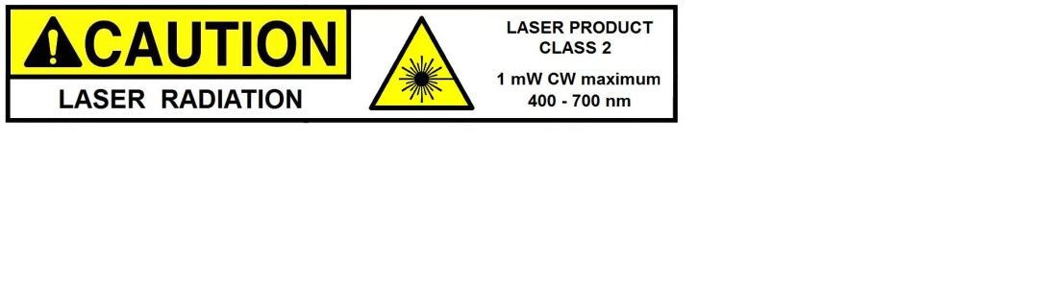****

### **PRE-OPERATIONAL SAFETY CHECKS**

1. **Ensure that materials and coating to cut are approved materials. Consult the Supervisor.**
2. **Only an inducted and competent person should be setting up and operating this equipment.**
3. **Safety guarding and magnetic lockout devices must never be removed or adjusted.**
4. **It is mandatory that an exhaust extraction system is attached to an operational laser cutter.**
5. **Visually check the area to ensure no slip or trip hazards are present in this workspace.**
6. **Be aware of other members and staff that may be in the immediate vicinity.**

#### OPERATIONAL SAFETY CHECKS

1. **Never attempt to use the laser without the proper induction.**
2. **Never run the laser without getting permission from the supervisor**
3. **All setting MUST be checked by the supervisor before starting the laser**
4. **The fume extraction system will turn on automatically.**
5. **Place your material on the table in the upper left corner – ensure the table is set low enough.**
6. **Set height using the height setting tool**
7. **Close the safety guard door (lid or cover) before operations can commence.**
8. **From the computer dashboard control, set the speed and power, etc. for the material.**
9. **To run the job, press ‘ENTER’ on the laser.**
10. **The fume extraction system will turn on automatically.**
11. **The carriage will move from its park position to the point of first engraving or cutting.**
12. **The process is now automatic until all passes are complete.**

#### HOUSEKEEPING

1. **DO NOT leave the laser running unattended. Use the ‘PAUSE’ button to pause the job.**
2. **Always leave the grid and table tray clean and free of residue and debris.**
3. **Keep the work bench tidy and clean.**
4. **Remember to remove your USB from the computer.**

## POTENTIAL HAZARDS

◼ **Impact, pinch and crush points** ◼ **CO2 laser beam** ◼ **Electrical components**

◼ **Flammable materials** ◼ **Eye injury** ◼ **Manual handling**

◼ **Noxious or toxic gases and fumes** ◼ **Failure or malfunction** ◼ **Failure or malfunction**

Reviewed May 2018 V2  
Uncontrolled when printed.

Uncontrolled when printed

This SOP does not necessarily cover all possible hazards associated with the tool and should be used in conjunction with other references. It is designed to be used as an adjunct to teaching Safety Procedures and to act as a reminder to users prior to tool use.

© State of Queensland (State Library of Queensland) 2020

This policy is licensed under a Creative Commons Attribution 3.0 Australia licence. You are free to copy, communicate and adapt this work, so long as you attribute the State Library of Queensland.

image001  image002

For more information see <http://creativecommons.org/licenses/by/3.0/au>