|  |  |
| --- | --- |
| **SAFE OPERATING PROCEDURE**  **3D PRINTER** | |
|  | |
| **DO NOT** use this machine unless you have completed an induction and the Supervisor has given permission | |
|  | |
| Hand Protection circle Gloves should be worn to avoid burns when handling hot plastics | Hair Protection circleLong and loose hair must be contained or restrained. |
| **CAUTION** &  **WARNING** signs commonly displayed on this machinery indicate a potentially hazardous situation which, if not avoided, may result in minor or moderate injury | |

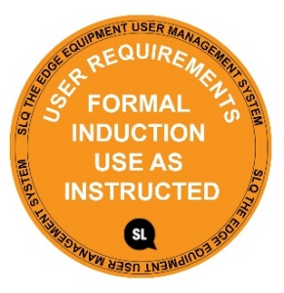

### **PRE-OPERATIONAL SAFETY CHECKS**

1. **Clean the build plate before starting a print job.**
2. **Be aware that some plastic vapours are toxic. Ensure that the ventilation fan is on.**
3. **For a catastrophic failure press the Reset button. This will abort the job and force a full reset of the printer.**
4. **Faulty equipment must not be used. Immediately report any suspect equipment or machinery.**

#### OPERATIONAL SAFETY CHECKS

1. **Familiarise yourself with all machine operations and controls – refer to the User Manual.**
2. **The printer will automatically check the temperatures of the nozzle and the bed; printing will start when the desired temperature is reached - that can take several minutes**
3. **Watch the first few printed layers to be sure filament has attached to the bed properly (5 to 10 minutes).**
4. **DO NOT TOUCH any moving parts during operation.**
5. **Wait for build plate to cool before removing.** **Remove the steel sheet from the printer and bend it slightly; prints should pop off.**
6. **Always wear safety glasses and gloves when removing support materials.**

#### HOUSEKEEPING

1. **Ensure all printed material is removed from the build plate.**
2. **Return all accessories. Leave the machine and work area in a safe, clean and tidy state.**

## POTENTIAL HAZARDS

◼ **Hot surfaces and materials** ◼ **Molten plastics** ◼ **Moving components**

◼ **Sharp edges** ◼ **Eye injury** ◼ **240v electrical components**

◼ **Toxic vapours** ◼ **Control errors** ◼ **Failure or malfunction**

This SOP does not necessarily cover all possible hazards associated with the tool and should be used in conjunction with other references. It is designed to be used as an adjunct to teaching Safety Procedures and to act as a reminder to users prior to tool use.

© State of Queensland (State Library of Queensland) 2020

This policy is licensed under a Creative Commons Attribution 3.0 Australia licence. You are free to copy, communicate and adapt this work, so long as you attribute the State Library of Queensland.

image001  image002

For more information see <http://creativecommons.org/licenses/by/3.0/au>

Reviewed May 2018 V2  
Uncontrolled when printed.

Uncontrolled when printed