Fan into generator

Step 2: Disassemble

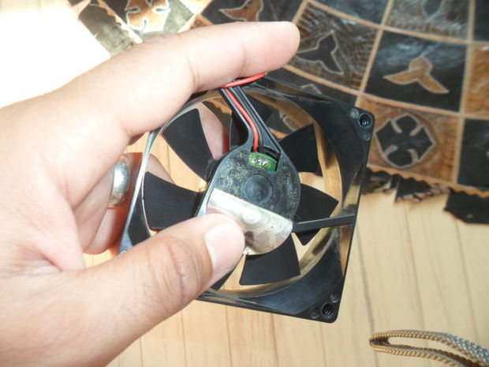

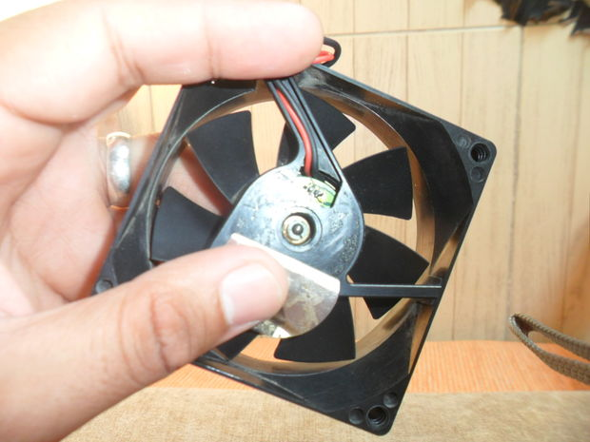

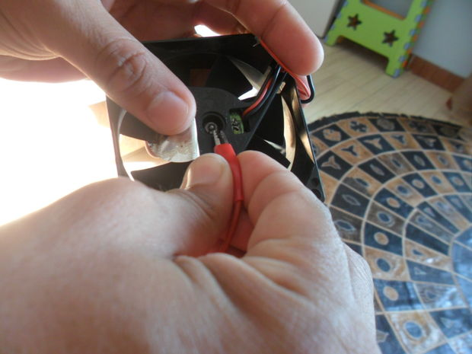

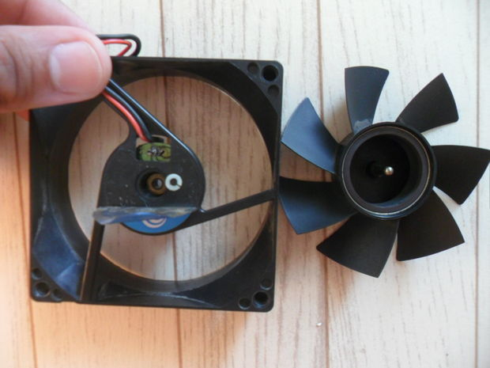

This is what I 'll show you how.
First remove sticker on the back of the fan.
Then you 'll find a small piece of plastic lock that holds Fan shaft secured , Don't brake it. Remove it with a crocodile clip .

Step 3: Winding Soldering

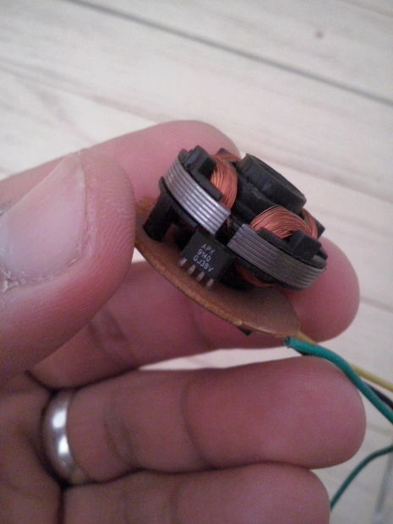

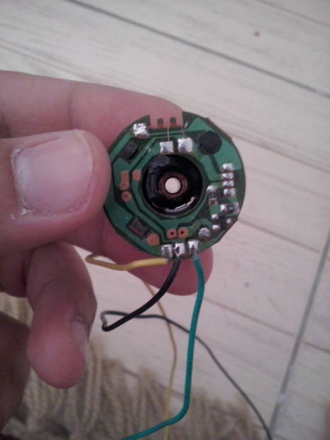

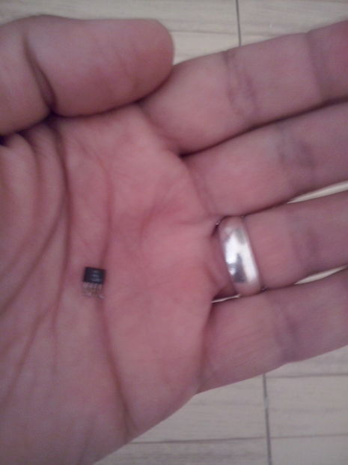

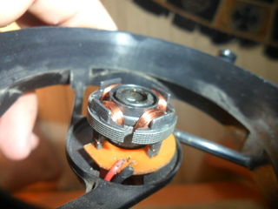

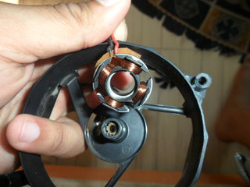

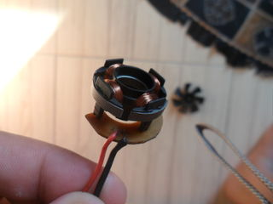

You can see 4 poles of winding connected in series and have only 2 terminals. To get the induced current , connect supply wires to those terminals and let the fan rotate.
With a solder iron , gently remove solder under IC pins and then remove the IC.
Remove any surface mount resistors or transistors.
Remove the supply wires form there place to put them in the holes of the removed IC.
Connect the supply wires in the winding terminals .
Make sure that you connect the terminals ( from which you will get the generated Voltage ) in a way that makes the two sets of winding connected in series.

Step 4: Final

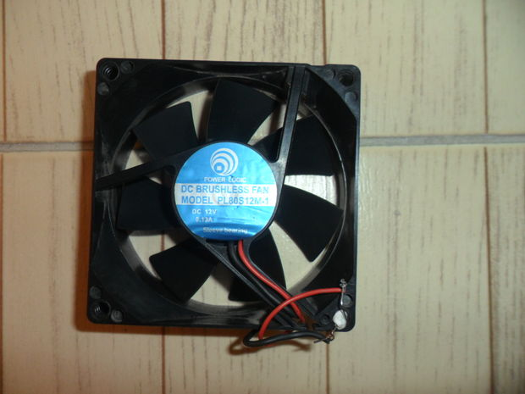

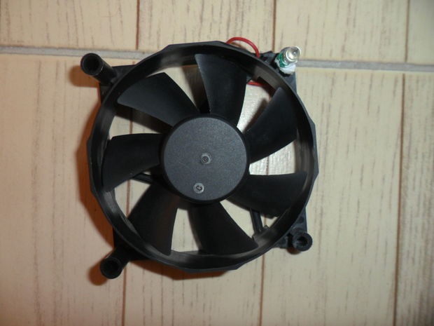

Videohttps://www.facebook.com/photo.php?v=10152946131930113&l=317628537734358881Assemble the fan in its place and lock it with the piece of plastic I told you about.
Put back the sticker.
Connect LED terminals to the Supply wires. Don't worry about +ve and -ve terminals , the LED will light if you connect it any way , trust me.
Roll the Fan
This video shows the fan in action.
Video is in the frame on the upper photo. And you can also find it here

https://www.facebook.com/photo.php?v=10152946131930113&l=317628537734358881
Here is the link to the project on my blog
http://embedded-egypt.blogspot.com/2013/07/pc-fan-wind-turbine.html

