Meet The Brett
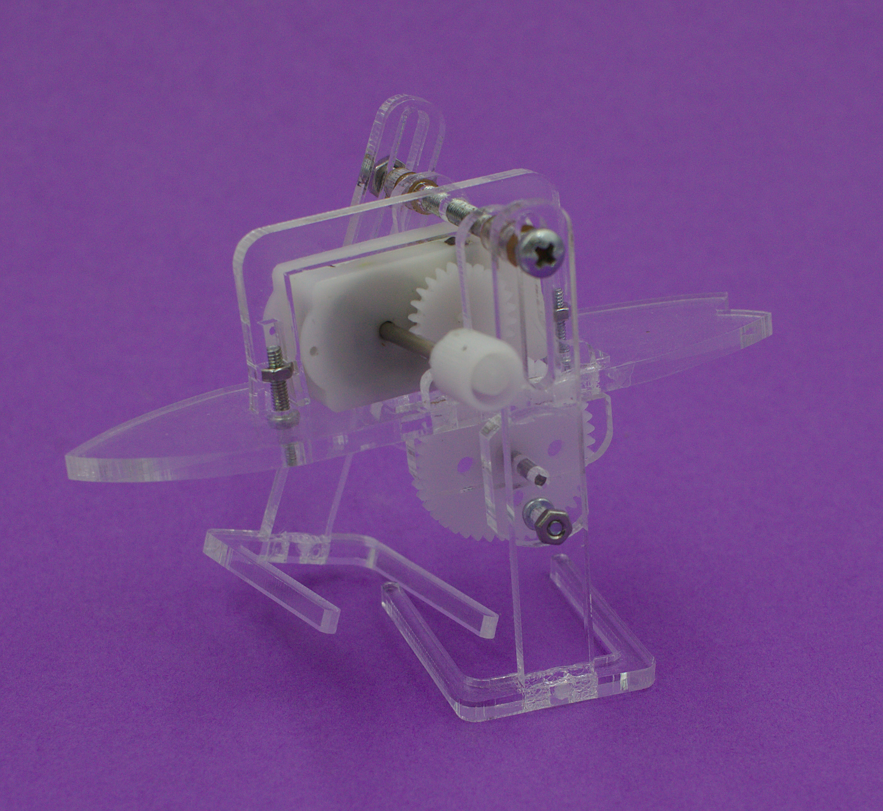

Summary

Materials

Body
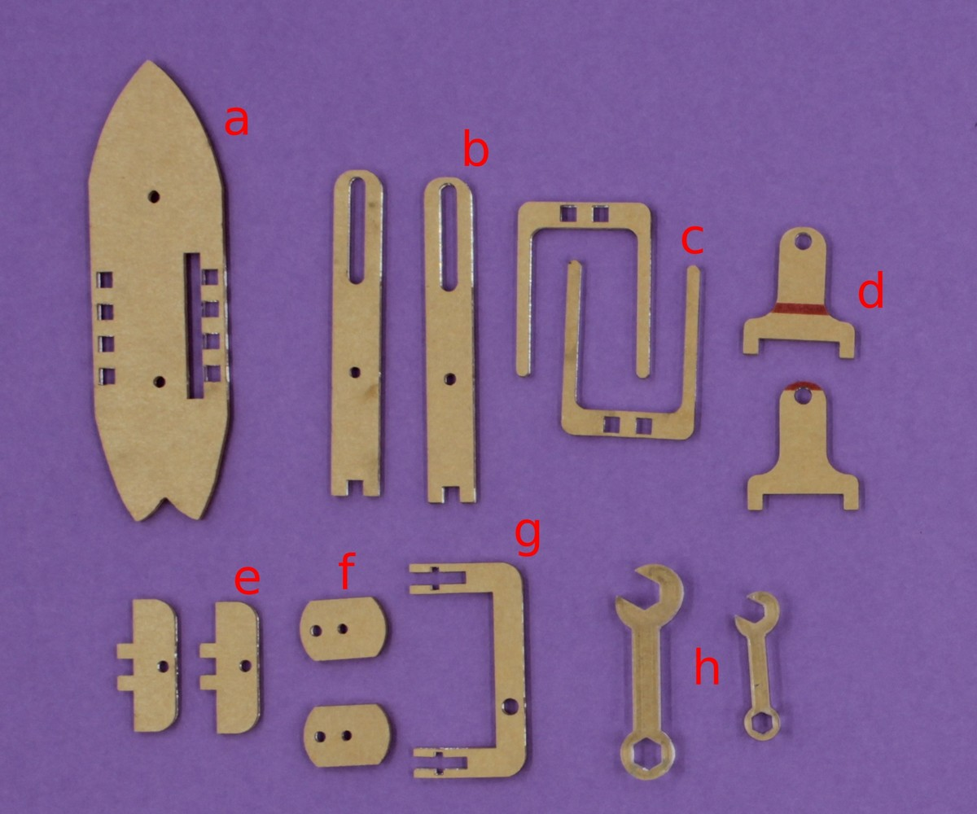
- surfboard body (a)
- 2 x legs (b)
- 2 x feet (c )
- 2 x bell shaped pieces (d)
- 2 x Long D pieces (e)
- 2 x cam hubs (f)
- Motor bracket (g)
- 2 spanners small and large (h)

Mechanism
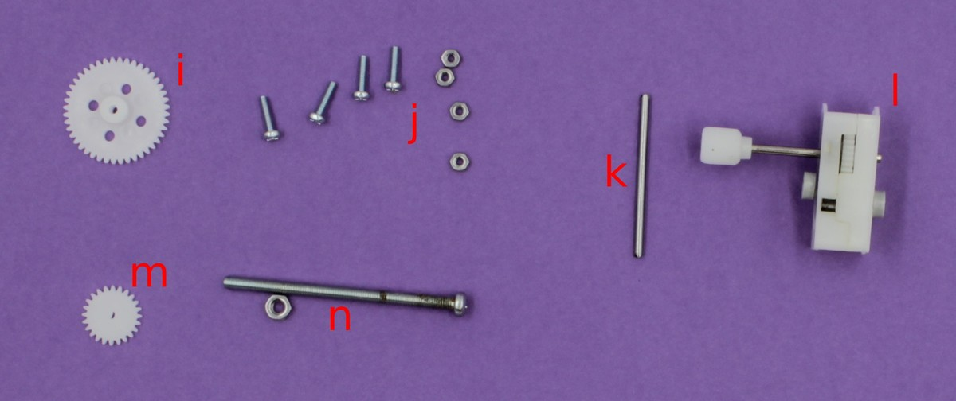
- 1 large gear (i)
- 4 2mm screw and bolts (j)
- 1 34mm shaft (k)
- 1 motor (l)
- 1 small gear (m)
- 1 long 3mm screw and bolt (n)
- spacers (o) - not shown

Instructions
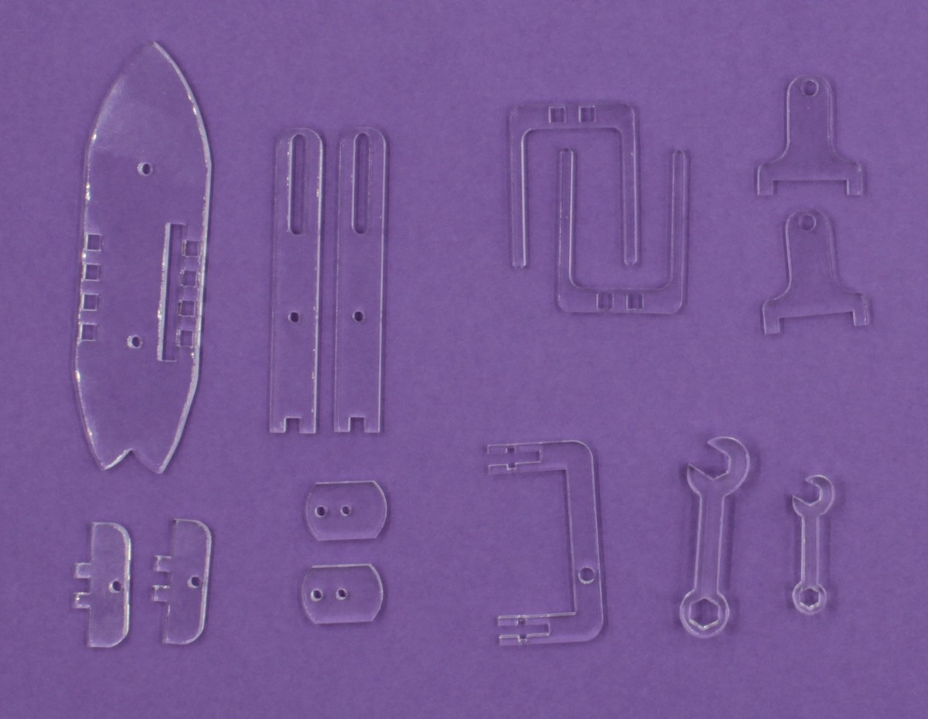
Peel plastic off laser cut parts
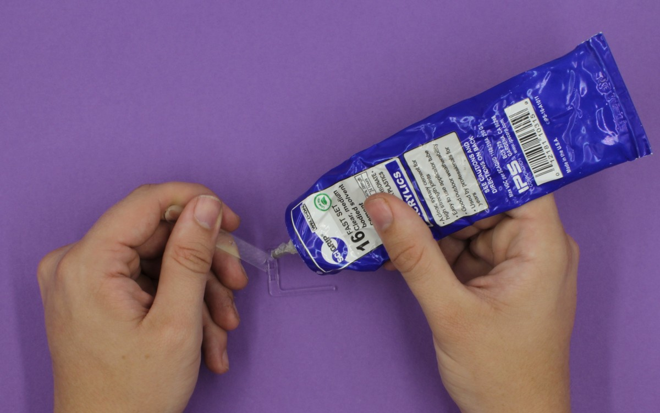
Glue feet ( c ) to legs (b)
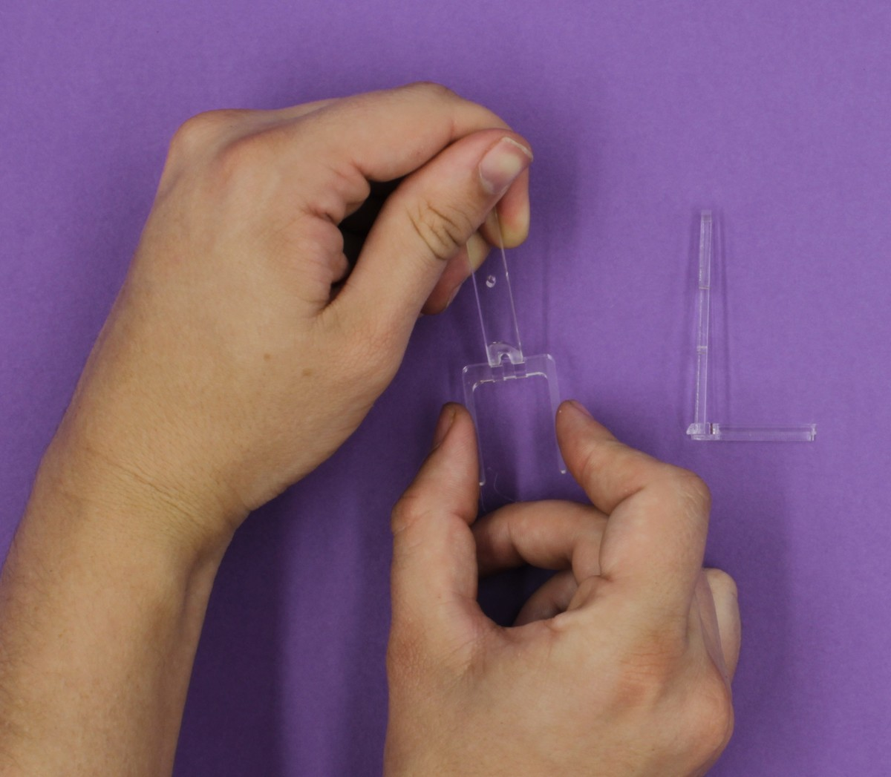
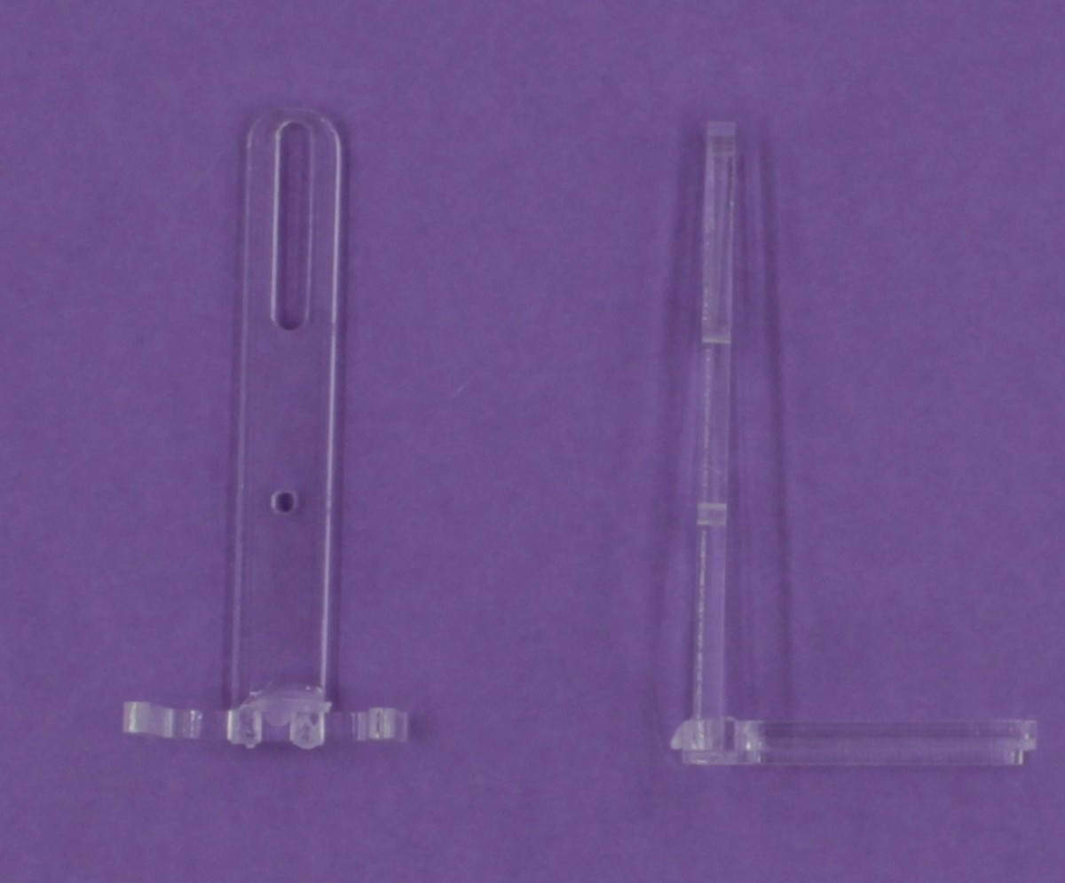
Glue bell shaped pieces (d) to one side of surfboard (a) with small amount of glue
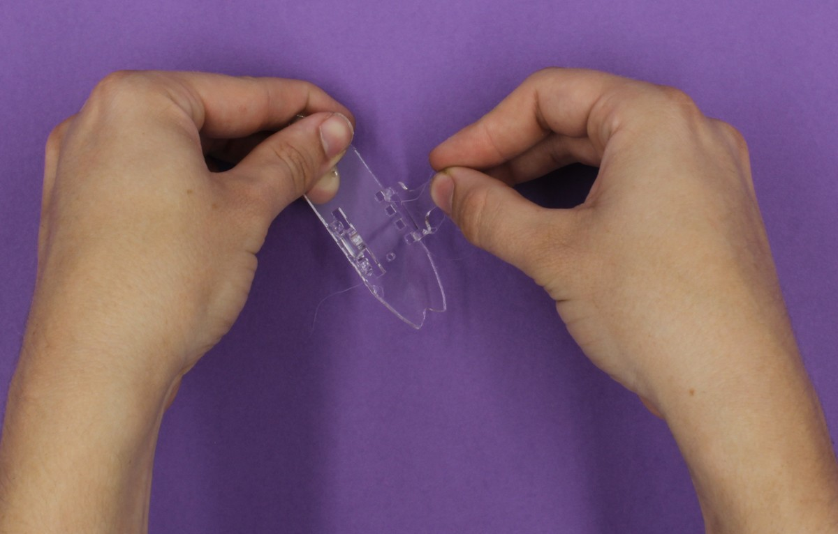
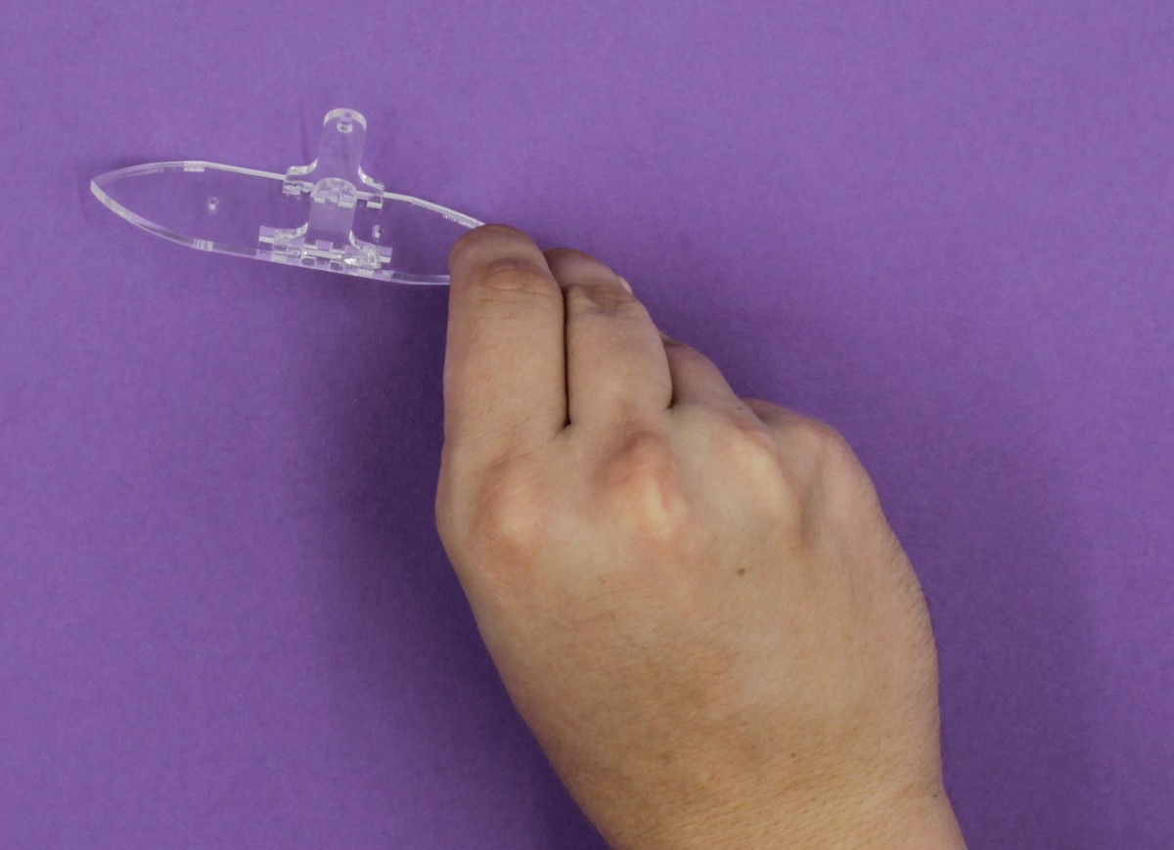
Push the shaft (l) through the centre of the large gear (i) being extra careful not to push the shaft through your thumb
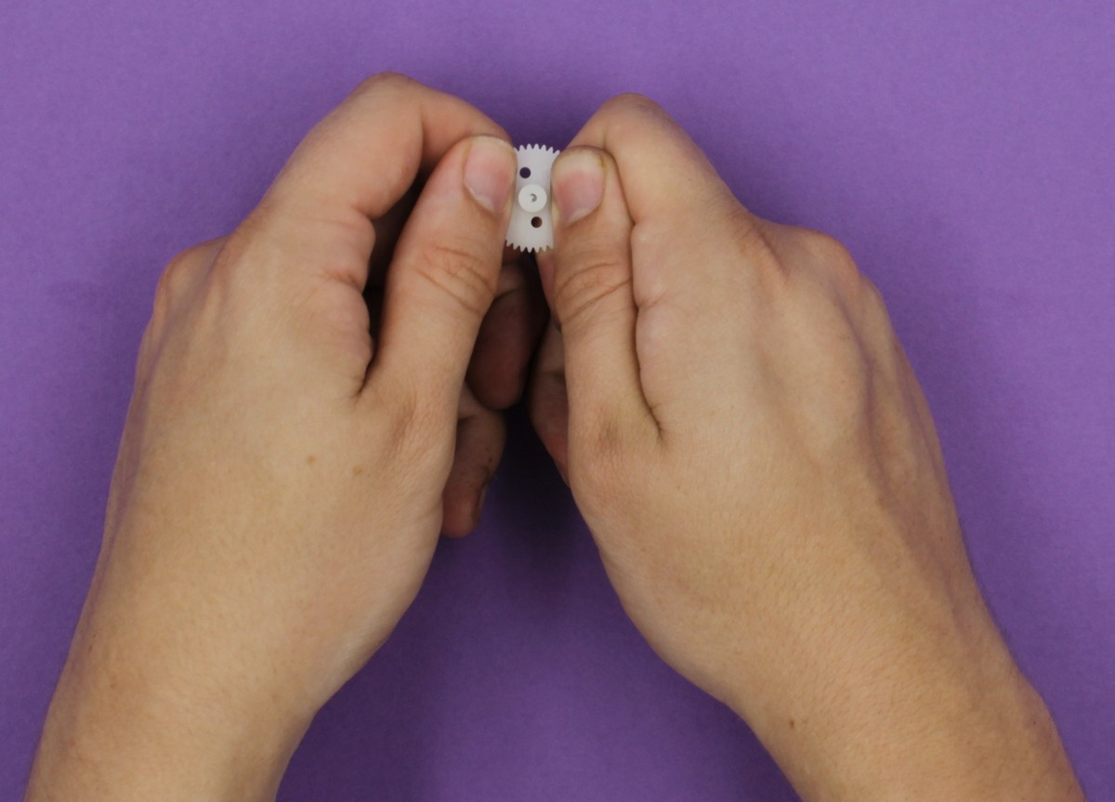
Align the shaft as shown in the picture
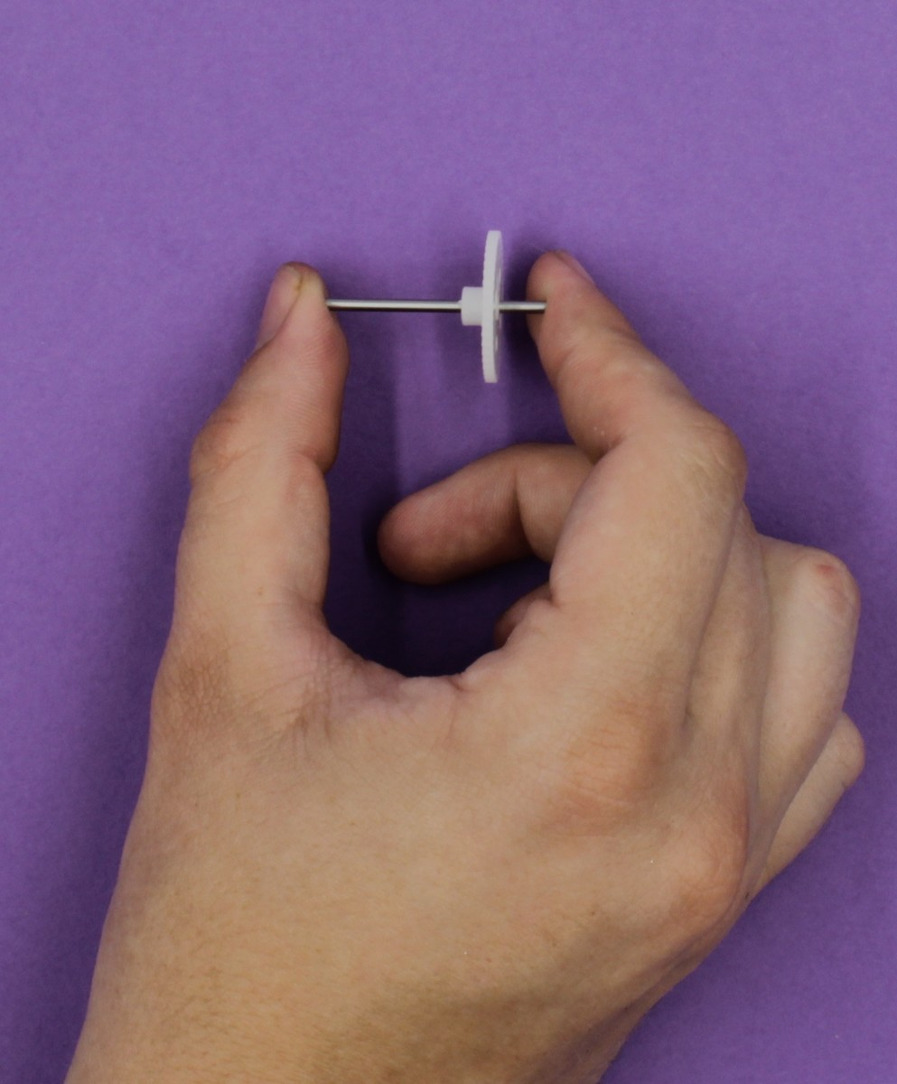
Place the D shaped pieces (e) on the shaft and apply a small amount of glue to the tabs
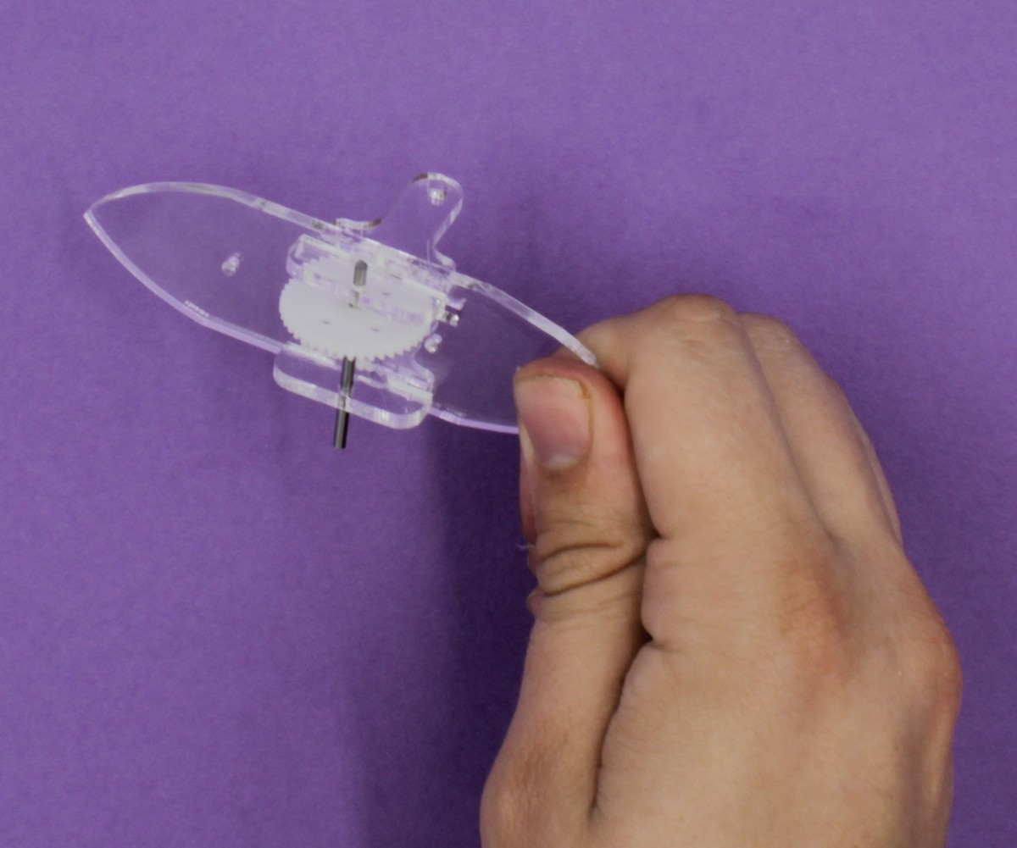
Insert so the large gear fits in the slot of the surfboard
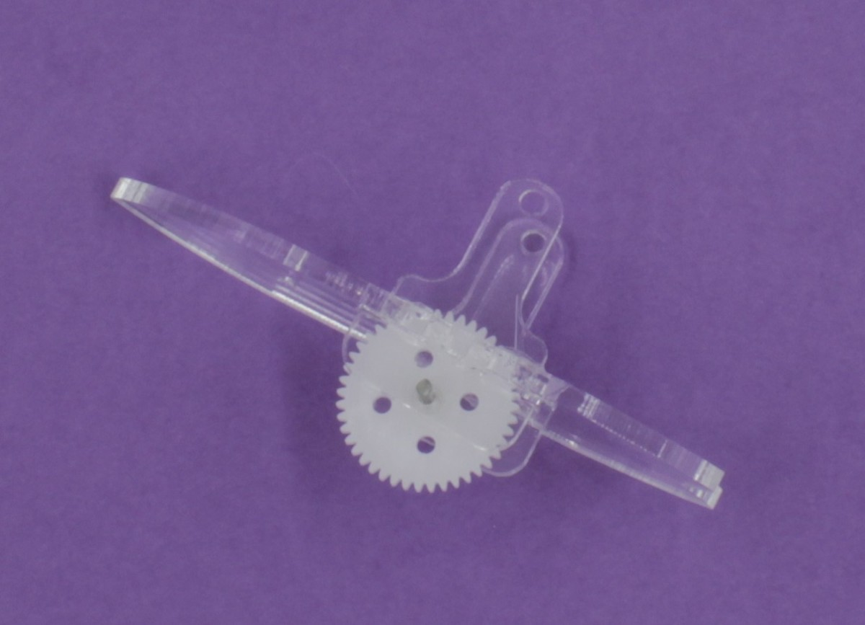
Then screw the cam hubs (f) onto the inside of the legs so that they are on the same side as the “toes”
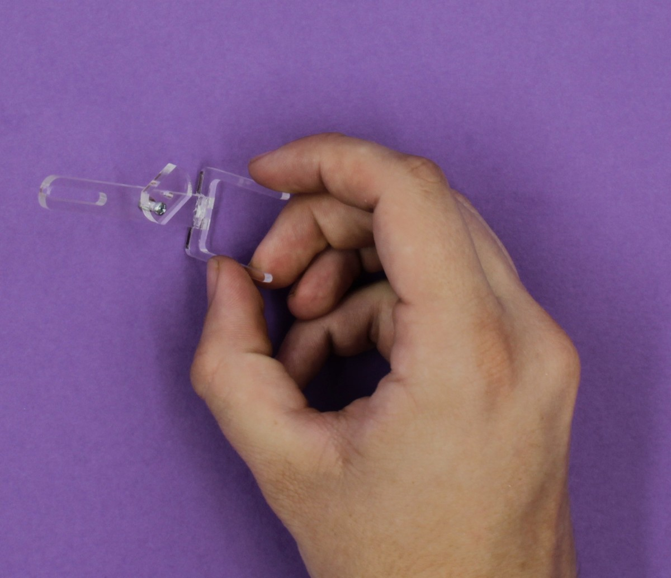
Attach the small gear (m) to the motor (l) carefully as the shaft is keyed with a D shape on the opposite side to the winder
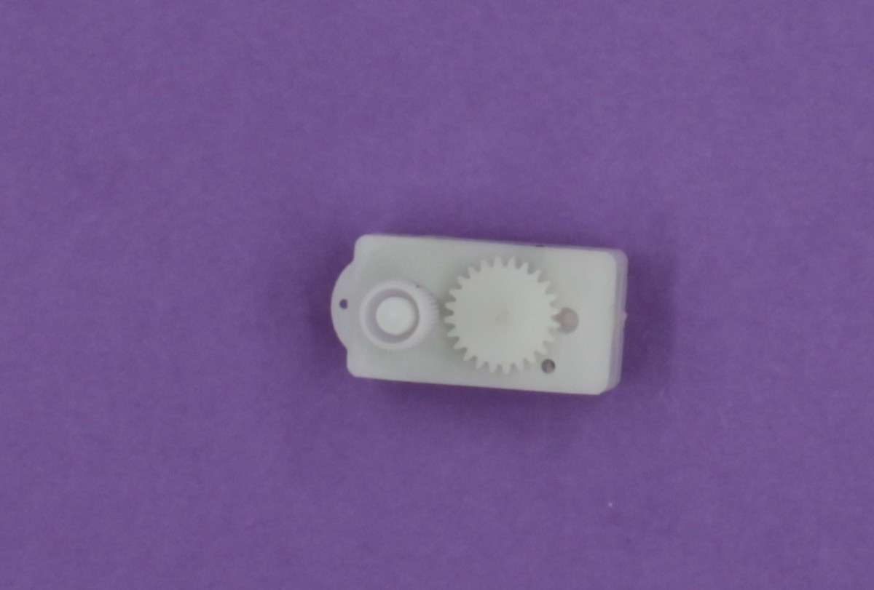
Put the two remaining screws (j) up through the body with the nuts on the side of the robot with the bell shaped pieces
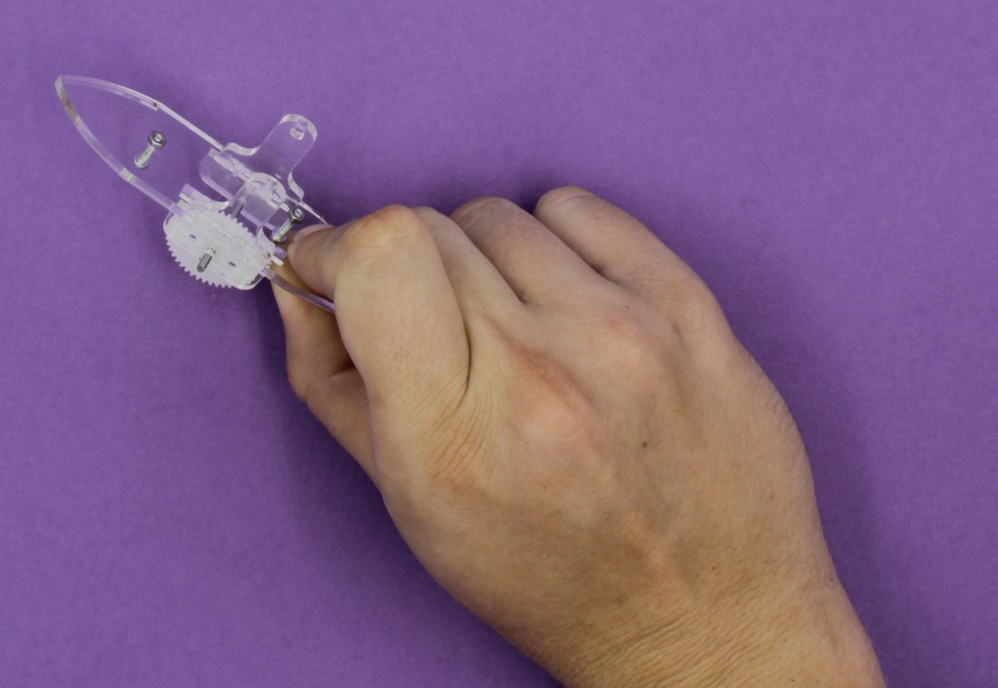
Place the motor on the robot and slot the bracket (g) over it with the bolts sliding into the holes ensuring that the hole in the bracket aligns with the hole in the top of the bells
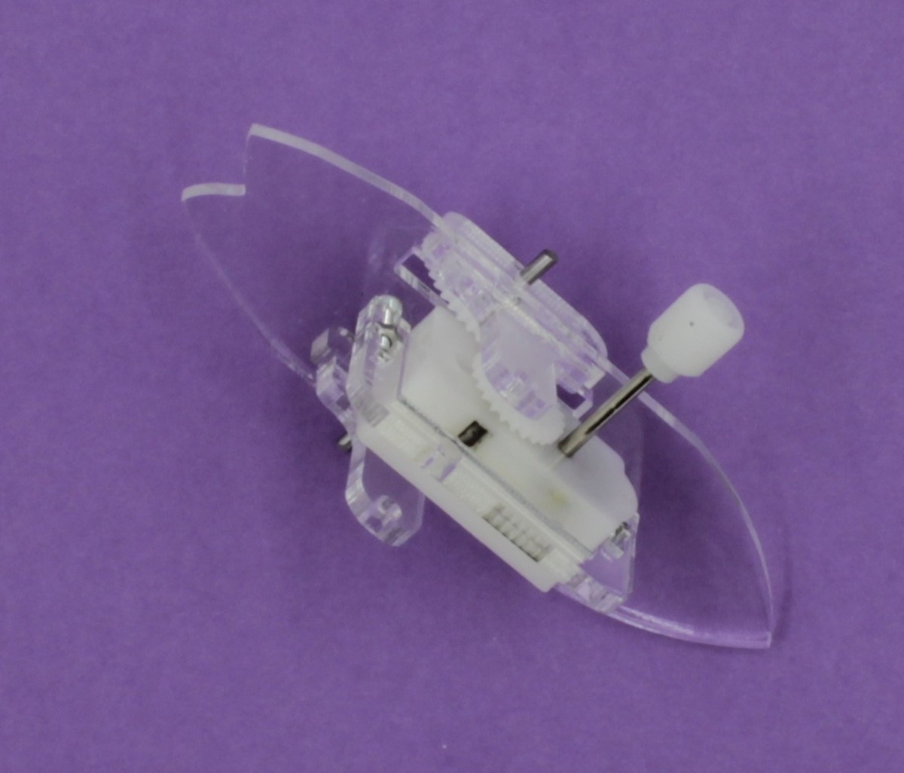
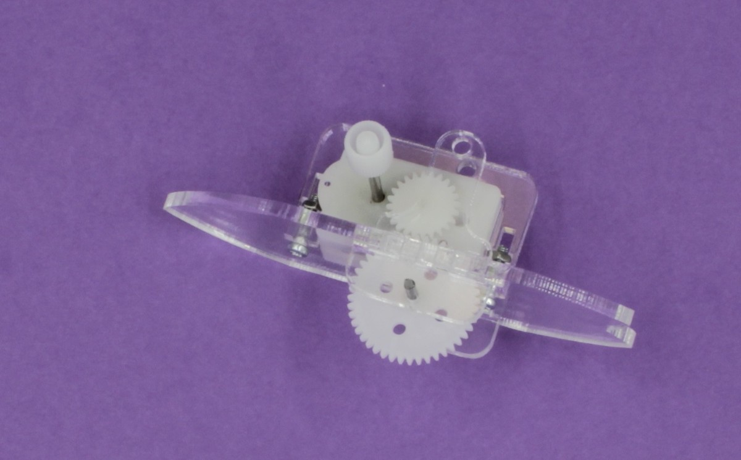
Push the cam hubs on to the shaft with the left hub pointing up and the right hub pointing down
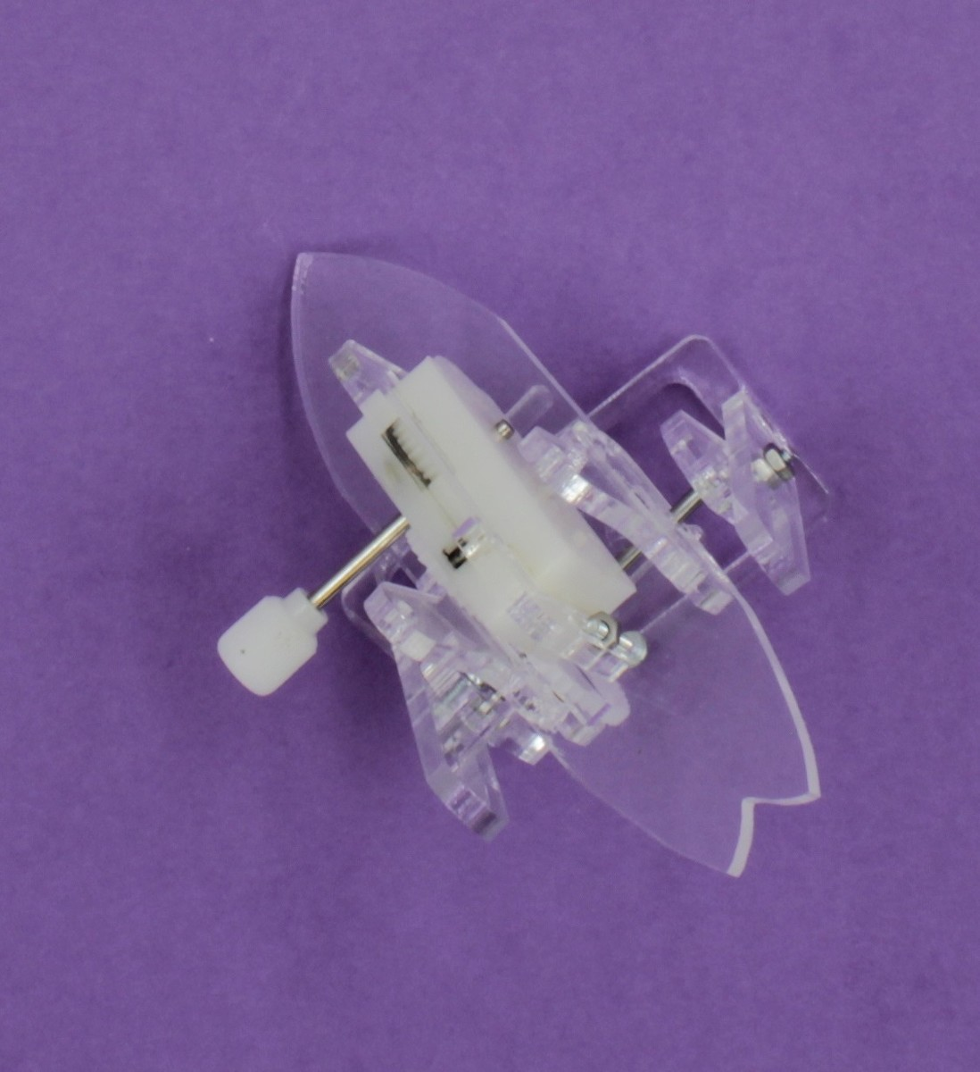
Attach the large bolt and screw (n) to the top of the frame through the large slot in the legs, the two bell shaped pieces and the motor bracket using the spacers provided


