Make your own Vacuum Former
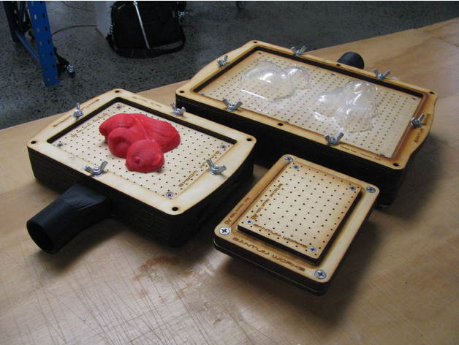
This activity has been fully documented as a HTE project here: Vacuum Former

Summary
3D printing is just the beginning, the gateway drug to all things additive and subtractive in the DIY manufacturing space. Come join The Edge team and explore the new frontier, building your very own vacuum former to make new and interesting things with. Belt buckles, chocolate moulds, packaging and so much more. Build one, own one and do awesome things with it for Christmas (or as a gift). It is an awesome opportunity to recycle all those plastic milk bottles.
Experience Nope, none required, just a willingness to play.
Cost $85

