Milkcrate Shelving
An interpretation of the basic ikea shelves for storing cubic items (ie milkcrates). This is a parametric design made in autodesk Fusion360.

Getting Parametric
So what parameters do we need to think about before we start?
- crate = crate dimension - this is a cube measured in mm.
- shelves = number of shelves (dimensionless) - this is used to calculate the height in mm.
- Compartments = number of compartments (dimensionless) - this is used to calculate the width in mm.
- thickness = the material sheet thickness in mm.
- tool thickness (tool)
Once you enter these parameters the model will calculate the largest router bit size based on your material thickness that can be used and display it as teh toolmax parameter. Then you can set your tool diameter. This can go as small as .5mm which is useful for the lasercutter.
Lets make a smaller set of shelves on the multicam M-2412

Fusion360
Grab this file and open it in Fusion360.
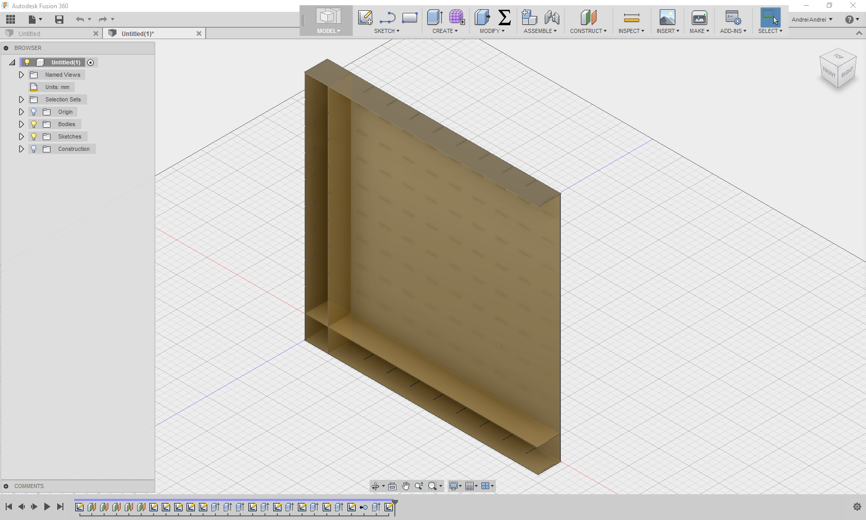
Now go to the modify menu and select change parameters
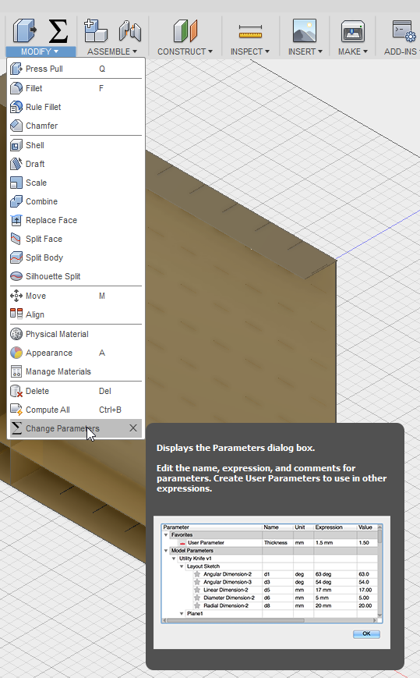
Here you can adjust the build to your needs. You should only change the expression field in these favourite parameters. I've modified it to fit on a sheet of mdf 2000 x 900 x 16. With 2 shelves, 3 compartments, 16mm thickness and a crate of 375 mm.
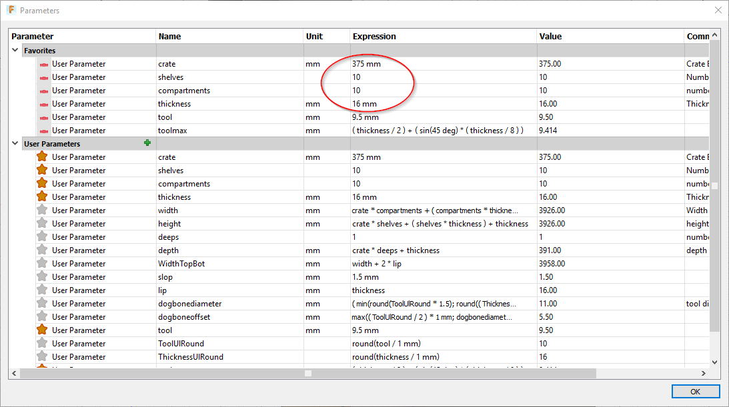
Check out the toolmax parameter value. It suggests I can get away with a tool up to 9.5mm (round it to the nearest .5 mm)
- toolmax - this is calculated based on the thickness of your material, round it to the nearest .5 of a mm. For example the biggest tool you can use with 16mm material is 9.41mm (9.5mm)
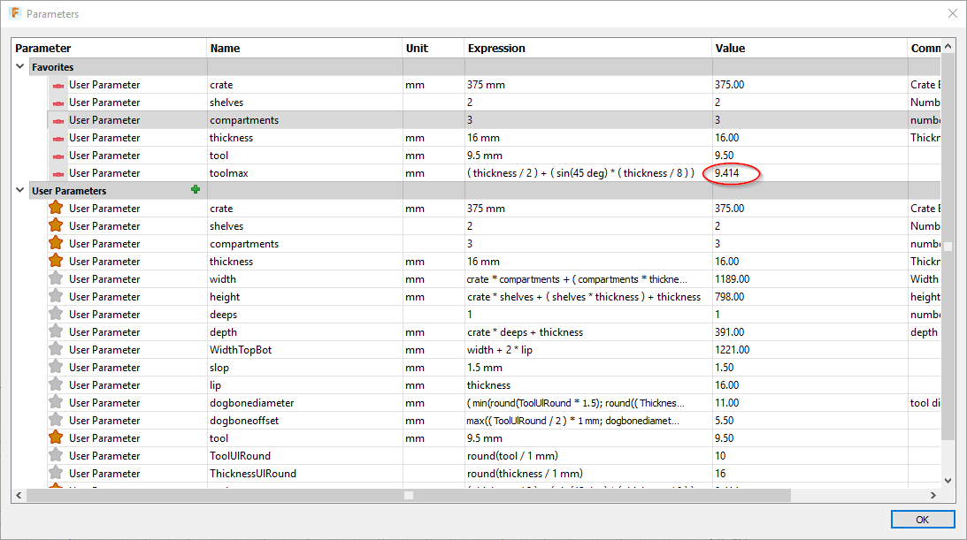
In this case I'm going to use a 6.35mm tool for a nicer finish.
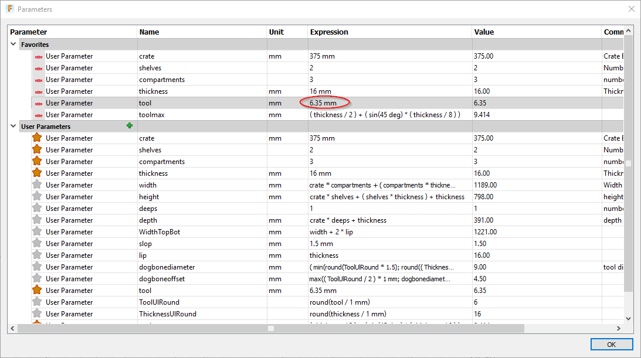
Now close the parameter window and check out your model.Looks a bit more reasonable now?
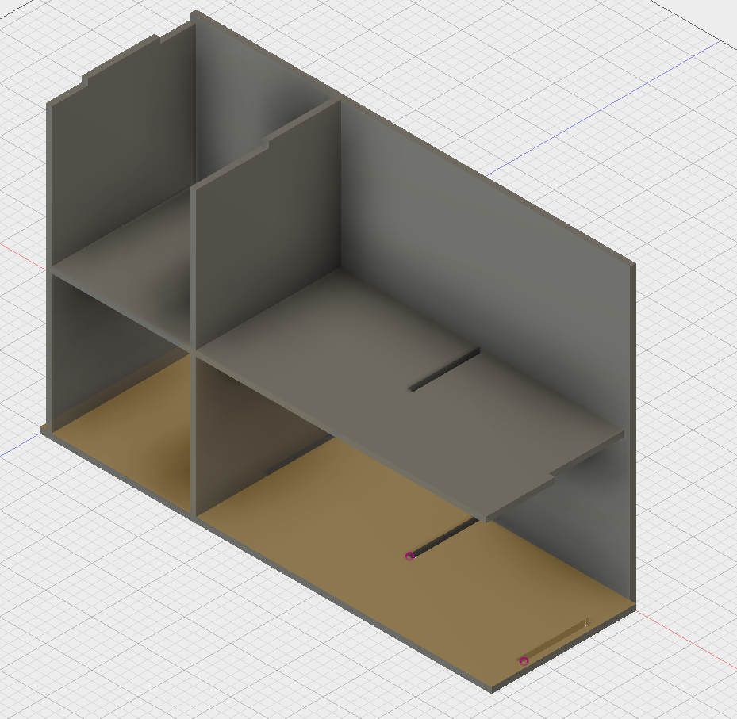
Now we need to export our DXFs for cutting, which we do from a 2D sketch. 1) The Sketches we want to export are called (partname)DXF. I'm going to export the SideDXF first by right clicking and selecting export to DXF.
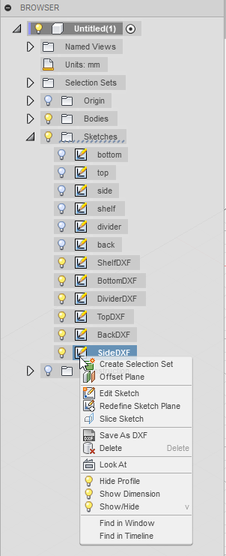
Then save it with a nice name..
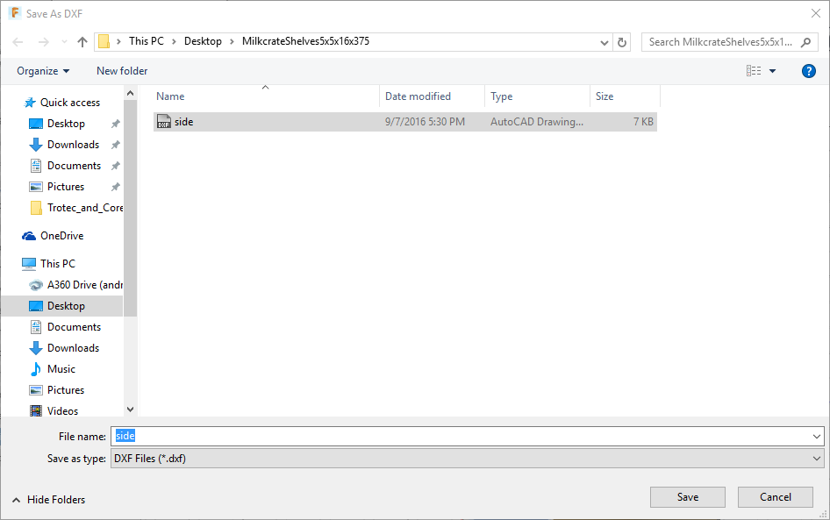
Now repeat for all the other sketches named DXF and you are done!!

Cutting on The Edge CNC router
To cut on the CNC router you first need to be inducted and make a booking.

1) To make the sketches neat for export I've gone through and extruded bodies from the original sketches then created new sketches on the extruded faces. This gets rid of the construction lines…

