ICT Training
  accessing_lyndacom - Workshop resources to demonstrate accessing Lynda.com |   Telstra Tech Savvy Seniors has a range of short training videos for the Tech Savvy Seniors program ranging from Mobile Devices, Computers and Internet Security, Using Email and other Programs as well as other technology. |   Be Connected is an Australia wide initiative empowering all Australians to thrive in a digital world. They have online learning resources as well as a Network of community partners. | 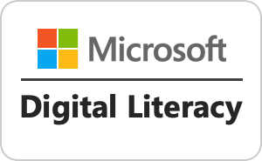  Microsoft Digital Literacy - To keep up with the pace of changing technology Microsoft has updated their popular digital literacy course with more relevant content, improved accessibility and an enhanced learning experience.
  Lynda.com is rebranding to LinkedIn Learning
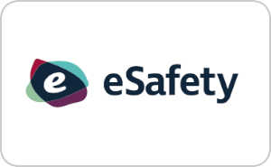  eSafety Education - The Office of the eSafety Commissioner has a collection of Education Resources and Policies in the context of being safe online | 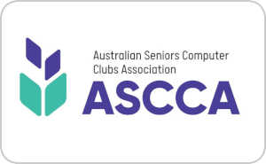  Australian Seniors Computer Clubs Association (ASCCA) is the national peak body for seniors and technology, aiming to assist clubs to educate seniors in using computer technology to enrich their lives and make them more self-reliant | 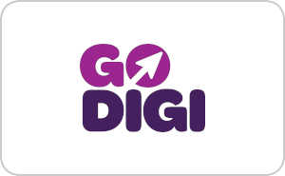  Go Digi - A partnership between Infoxchange and Australia Post to develop a national four year digital literacy program to improve the digital skills of Australians. | 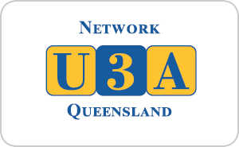  U3A Queensland is the largest provider of adult education programs for retirees within Queensland.
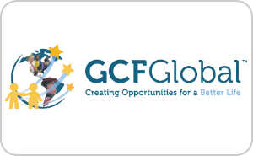
GCFLearnFree.org has helped millions around the world learn the essential skills they need to live and work in the 21st century. From Microsoft Office and email, to reading, math, and more.

