Scratch
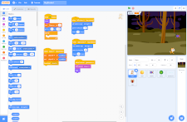
Scratch is a free, block-based editor that allows you to simply create stories, games and animations.
Scratch contains all the elements of typically coding languages such as variables and functions in a neat block-based interface.
Scratch is designed for 8 to 16 year olds, helping young people think creatively and systematically.
For younger coders, Scratch also has the sibling app Scratch Jr.
Recommended Ages | Year 3 to Year 11 (ages 8 to 16)
Product Cost | Free
Where to Purchase | Scratch

Resources
- Creating Basic Animation in Scratch
- Lets create characters that respond to the keyboard

Activities
- Scratch Game Making Series

