NAO Cadet
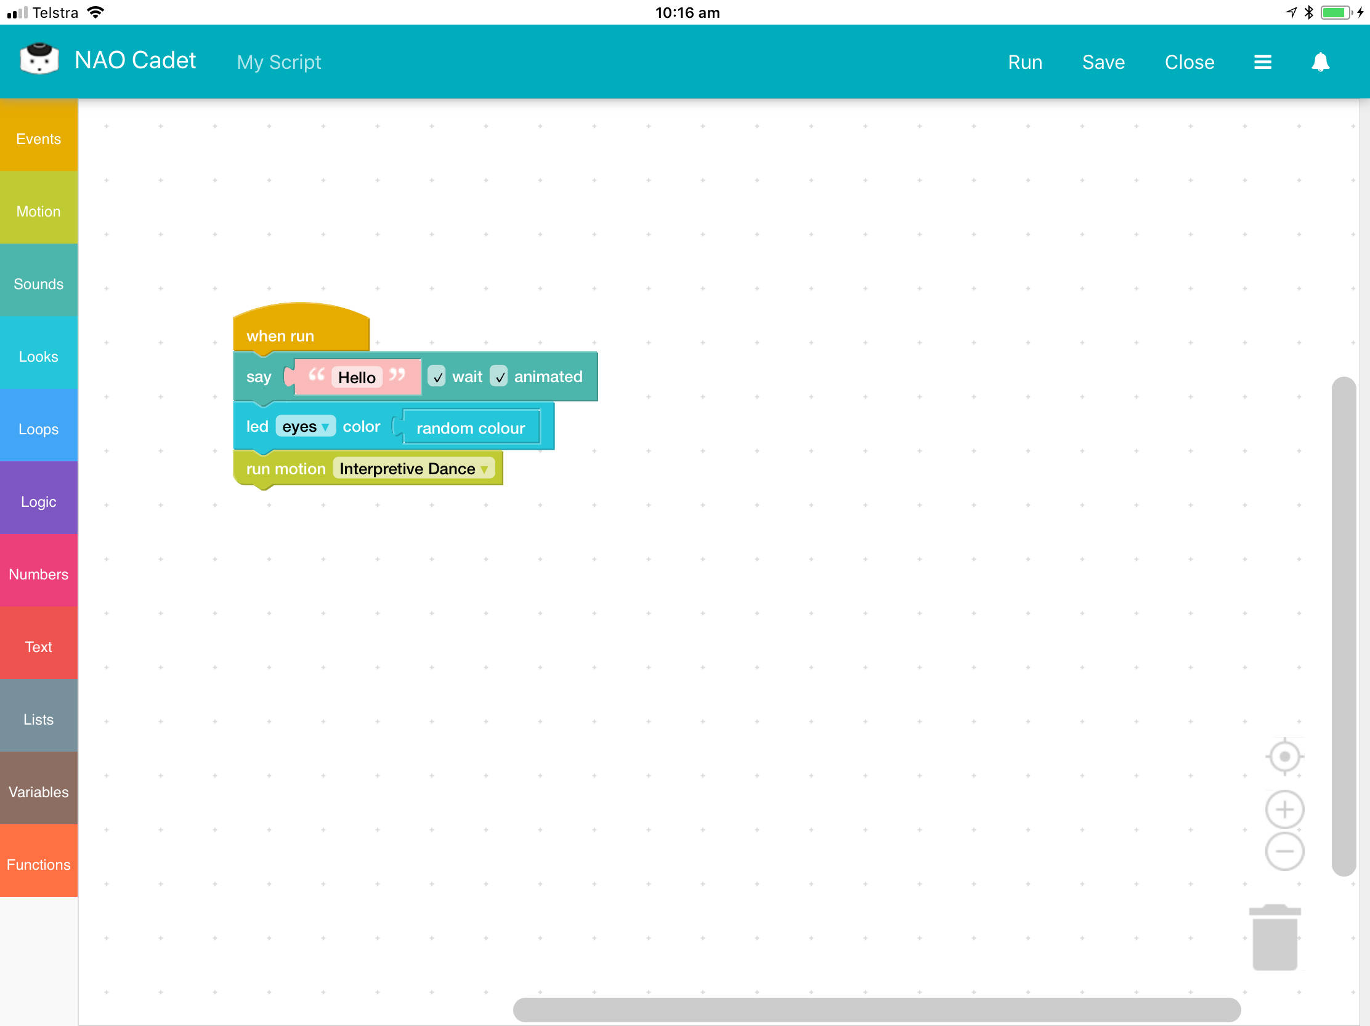
NAO Cadet is a combination of a Choreographe app and Android/iOS/Web app that allows young kids to program the NAO using block based programming.

Usage
Upload the Choreographe app to your NAO and launch it by saying the keyword cadet. The NAO will announce its web address which you can connect a web-browser and start coding!
Alternatively with the choreographe app running, launch the Android or iOS app to start.

Downloads
- Choreographe App
- Android App
- iOS App

Support
As NAO Cadet is an opensource product, support is provided over on GitHub. There you will find more information around installation and usage, tips and known issues.
If you have any questions about this software, please contact James Collins, Inclusive Communities at james.collins@slq.qld.gov.au or on 07 3842 9978.

