LEGO WeDo
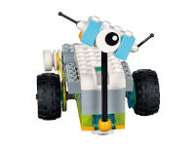
The LEGO Education WeDo 2.0 Core Set & Software builds on the innovative learning experience of the original platform by giving you a new brick set, improved technology and opportunities to meet science standards in a fun, engaging way. Complete with relevant, real-world projects. Designed for a younger audience than lego_mindstorms, it is a great starting point into the world of engineering.
Recommended Ages | Year 1 to Year 4 (ages 6 to 10)
Product Cost | $280-$340
Where to Purchase | Can be purchased from larger toy/educational stores or Modern Teaching Aids

Product Requirements
- The coding system requires a tablet

Loanable Kits
State Library has kits of this item available for loan to libraries within the Regional Libraries Queensland and Indigenous Knowledge Centres network. Libraries can place a reservation through the Aurora catalogue (availability is subject to existing reservations, loans and associated return dates).
The kits are for use by patrons within the library only, as part of supervised library programming. They will not be listed in the public online catalogue for personal reservation.
Please contact Access Services, or phone 07 3842 9014 with any queries.

Use In Libraries

Cook Shire Libraries
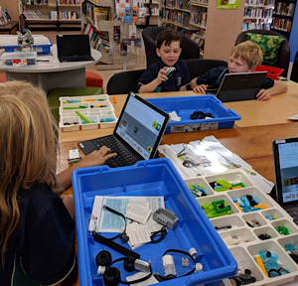
Using Tech Savvy Regional Queensland grant funding, Cook Shire Council partnered with the local schools to facilitate STEM sessions at the Cooktown and Bloomfield libraries using the LEGO WeDo, engaging youth to build confidence, digital and motor skill development with coding and robotics. In these sessions, children built and coded LEGO WeDo slugs, helicopters and fans.

Resources

Models
- LEGO WeDo Building Instructions
- LEGO WeDo 2.0 Building Instructions

Video Tutorials
- Windmill Instructions
- Buggy Instructions
- WeDo Programming Basics

