Drones
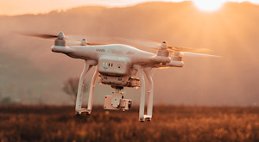
Drones can not only provide a lot of fun for recreational purposes, they can also be used in commercial applications and have the possibility to interfere or cause hazards with other aircraft, buildings and equipment. Before using a drone, please visit the Drone Flyer website which can provide you information on where and how you can fly your drone.

Rules around using Drones
Regardless of if the drone is owned by a commercial entity, CASA’s commercial/recreational classification is based on how the drone is actually operated. For libraries, if a drone was loaned for fun, then the user would need to abide by the rules for recreational use, however if the drone was being used for a commercial purpose, they would be subject to the rules and requirements for commercial operation.
Commercial use is typically defined as ‘for hire or reward’.
As of 2018, the following restrictions apply:
- You can only fly drones during the day and must be within visual sight of yourself with your own eyes
- You can only fly your drone below 120M above ground
- Your drone must be at least 30M away from; and cannot be flown over or above people
- You must not fly your drone over or near emergency operations (such as a car crash)
- Your drone must be at least 5.5KM away from aerodromes and helicopter landing sites
- Never operate your drone in a hazardous way to other aircraft, persons or property
- Respect personal privacy and don't record people without their consent

